**Vehicle Loan-Hub**

**Overview:**

Welcome to **VehicleLoanHub**, where applying for vehicle loans is seamless for users and efficient for administrators. Users can easily apply for loans for cars, trucks, or motorcycles through our intuitive platform, while administrators can manage applications effortlessly. With real-time updates and analytics, users can track their applications, and administrators can make informed decisions. VehicleLoanHub simplifies the financing process, ensuring a smooth experience for all involved.

**Users of the System:**

1.    Admin

2.User

**System Architectural Diagram:**  
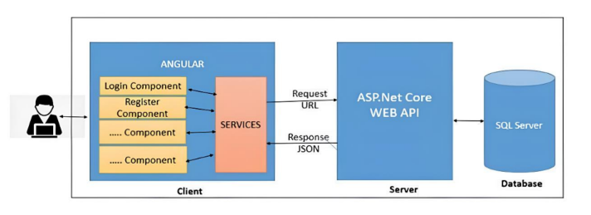

**Admin Actions:**

**Flow Diagram:**

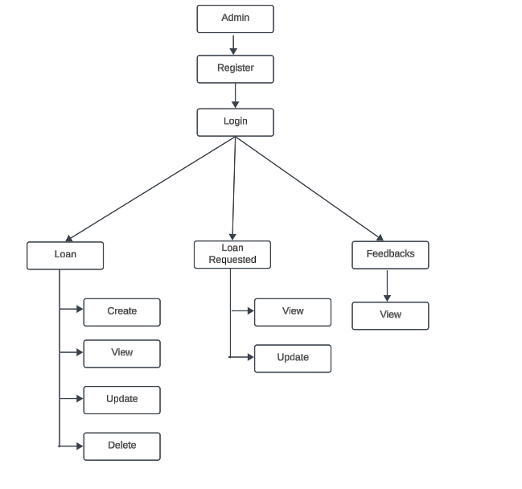

* **Loan**: Admins can view and create new loans by providing necessary information.
* **Loan Requested**: Admins can access and review applied loans, with the ability to update their status by approving or rejecting them.
* **Feedbacks**: Admins have the option to view user’s feedback.

**User Actions:**

**Flow Diagram:**

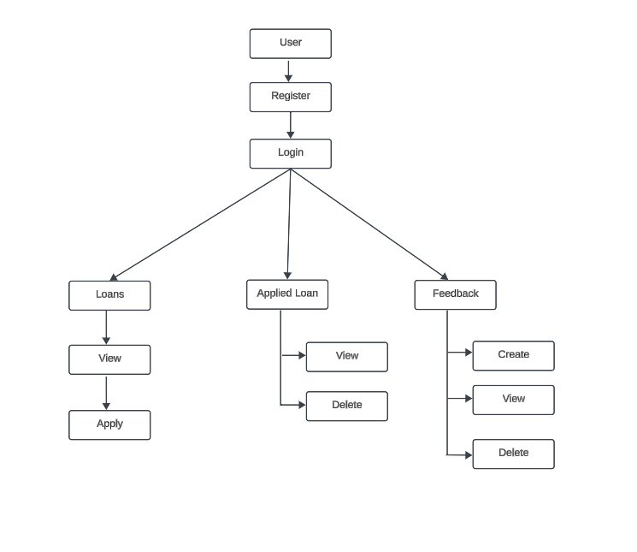

* **Loan**: Users can view and apply for the list of loans.
* **Applied Loan**: Users can view the list of applied loans.
* **Feedback**: Users have the option to create and view their feedback.

**Modules of the Application:**

**Admin:**

1. Register
2. Login
3. Home
4. Loan
5. Loan Requested
6. Feedbacks

**User:**

1. Register
2. Login
3. Home
4. Loans
5. Applied Loan
6. Feedback

**Technology Stack**

**Front End**

Angular 10+, HTML, CSS

**Back End**

.NET Web API, EF Core, Microsoft SQL Server Database.

**Application assumptions:**

1. The login page should be the first page rendered when the application loads.
2. Manual routing should be restricted by implementing Auth Guard, utilizing the canActivate interface. For example, if the user enters as http://localhost:8080/dashboard or http://localhost:8080/user the page should not navigate to the corresponding page instead it should redirect to the login page.
3. Unless logged into the system, the user cannot navigate to any other pages.
4. Logging out must again redirect to the login page.

**Backend Requirements:**

Create folders named as **Models, Controllers, Services, Data and Exceptions** inside **dotnetapp** as mentioned in the below screenshot.

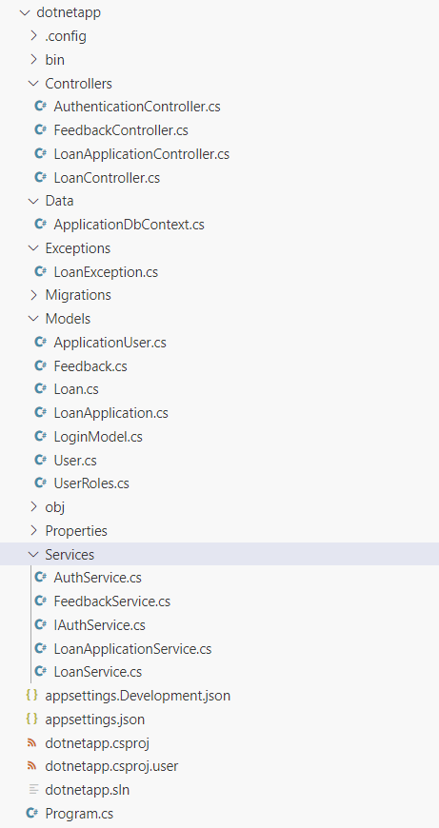

**ApplicationDbContext**: (**/Data/ApplicationDbContext.cs**)

Inside **Data** folder create **ApplicationDbContext** file with the following **DbSet** mentioned below

       public DbSet<User> Users { get; set; }

       public DbSet<Loan> Loans { get; set; }

       public DbSet<LoanApplication> LoanApplications { get; set; }

       public DbSet<Feedback> Feedbacks { get; set; }

**Model Classes:**

Inside **Models** folder create all the model classes mentioned below.

**Namespace**: All the model classes should located within the **dotnetapp.Models** namespace.

**User (Models / User.cs):**

This class stores the user role (Admin or User) and all user information.

**Properties:**

•   UserId: int

•   Email: string

•   Password: string

•   Username: string

•   MobileNumber: string

•   UserRole: string (**Admin/User**)

**Loan (Models / Loan.cs)**:

This class stores information about a loan.

**Properties:**

•   LoanId: int

•   LoanType: string

•   Description: string

•   InterestRate: decimal

•   MaximumAmount: decimal

**LoanApplication (Models / LoanApplication.cs)**:

This class represents a loan application.

**Properties:**

•   LoanApplicationId: int

•   UserId: int

•   User?: User

•   LoanId: int

•   Loan?: Loan

•   SubmissionDate: DateTime

•   Income: decimal

•   Model: DateTime

•   PurchasePrice: decimal

•   LoanStatus: int

•   Address: string

•   File: string

**Feedback (Models / Feedback.cs)**:

This class represents feedback submitted by users.

**Properties:**

•   FeedbackId: int

•   UserId: int

•   User?: User

•   FeedbackText: string

•   Date: DateTime

**LoginModel (Models / LoginModel.cs):**

This class stores the email and password to authenticate the user during login.

**Properties:**

•   Email: string

•   Password: string

**UserRoles (Models / UserRoles.cs):**

This class defines constants for user roles.

**Constants:**

1.  Admin: string - Represents the role of an admin user.

2.  User: string - Represents the role of a regular user.

**ApplicationUser (Models / ApplicationUser.cs):**

 This class represents a user in the application, inheriting from **IdentityUser** class.

Property:

•  Name: string (Max length 30)

**Exceptions: (Exceptions / LoanException.cs)**

1. Inside **Exceptions** folder create the exception file named **LoanException(LoanException.cs).**
2. **Purpose**: The **LoanException** class provides a mechanism for handling exceptions related to loan operations within the application.
3. **Namespace**: It should located within the **dotnetapp.Exceptions** namespace.
4. **Inheritance**: Inherits from the base **Exception** class, enabling it to leverage existing exception handling mechanisms.
5. **Constructor**: Contains a constructor that accepts a message parameter, allowing to specify custom error messages when throwing exceptions.

**For example**, you might throw a **LoanException**

1. When attempting to **delete a loan that is referenced by a loan application**.

2. When trying to **add a loan with the same loan type** as an existing one.

3. When attempting to **apply for a loan that has already been applied** for by the same user.

**Important note:**

Implement database logic only in the **service file functions without using try-catch**. Use **try-catch only in the controller files** and call the service file functions inside it.

**Services:**

Inside “**Services”** folder create all the services file mentioned below.

**Namespace**: All the services file should located within the **dotnetapp.Services** namespace.

**LoanService (Services / LoanService.cs)**

This service class provides methods to interact with loan data stored in the database.

**Constructor:**

public **LoanService**(ApplicationDbContext context)

{

_context = context;

}

**Functions:**

1. **public async Task<IEnumerable<Loan>> GetAllLoans()**:

a. Retrieves and returns all loans from the database.

2. **public async Task<Loan> GetLoanById(int loanId):**

a. Retrieves a loan from the database with the specified **loanId**.

3. **public async Task<bool> AddLoan(Loan loan):**

a. Check if a loan with the same type already exists in the database.

b. If a loan with the same loan type exists, throw a **LoanException** with the message “**Loan with the same type already exists”**.

c. If no loan with the same type exists, add the new loan to the database.

d. Save changes asynchronously to the database.

e. Returns **true** for the successfully insertion.

4. **public async Task<bool> UpdateLoan(int loanId, Loan loan):**

a. If no loan with the specified **loanId** is found in the database, return **false**.

b. Check if a loan with the same type already exists in the database.

c. If a loan with the same loan type exists, throw a **LoanException** with the message “**Loan with the same type already exists**”.

d. If **no loan with the same type exists**, update the existing loan with the values from the provided loan object.

e. Save changes asynchronously to the database.

f. Return **true** for the successful update.

5. **public async Task<bool> DeleteLoan(int loanId):**

a. Retrieve the loan from the database based on the provided **loanId**.

b. Save changes asynchronously to the database.

c. Check if the loan is referenced in any **LoanApplication**. If referenced, throw a **LoanException** with the message **“Loan cannot be deleted, it is referenced in loanapplication”**.

d. If the loan is not referenced by any **LoanApplication**, remove the loan from the database.

e. Save changes asynchronously to the database.

f.  Return **true** for the successful delete.

**LoanApplicationService (Services / LoanApplicationService.cs):**

This service class provides methods to interact with loan application data stored in the database.

**Constructor:**

public **LoanApplicationService**(ApplicationDbContext context)

{

_context = context;

}

**Functions:**

1. **public async Task<IEnumerable<LoanApplication>> GetAllLoanApplications():**

a. Retrieves all loan applications from the database.

2. **public async Task<IEnumerable<LoanApplication>> GetLoanApplicationsByUserId(int userId):**

a. Retrieves all loan applications associated with a specific **userId** from the database.

**3. public async Task<bool> AddLoanApplication(LoanApplication loanApplication):**

a. Check if the user already applied for this loan. (Checks if there is any existing loan application for the same loan (**LoanId**) and user (**UserId**) combination in the database.)

b. If such a loan application exists, it throws a **LoanException** with the message "**User already applied for this loan**".

c. If not, add the new loan application to the database.

d. Save changes asynchronously to the database.

e. Return **true** for the successful insertion.

**4. public async Task<bool> UpdateLoanApplication(int loanApplicationId, LoanApplication loanApplication):**

a. Retrieve the existing loan application from the database with the specified **loanApplicationId**.

b. If no loan application with the specified **loanApplicationId** is found, return **false**.

c. If found, update the loan application with the values from the provided **loanApplication** object.

d. Save changes asynchronously to the database.

e. Return **true** for the successful update.

**5. public async Task<bool> DeleteLoanApplication(int loanApplicationId):**

a. Retrieve the existing loan application from the database with the specified **loanApplicationId**.

b. If no loan application with the specified loanApplicationId is found, return **false**.

c. If found, **delete the loan application** with the provided **loanApplicationId**.

d. Save changes asynchronously to the database.

e. Return **true** for the successful delete.

**FeedbackService** **(Services / FeedbackService.cs):**

This service class provides methods to interact with feedback data stored in the database.

**Constructor:**

public **FeedbackService**(ApplicationDbContext context)

{

_context = context;

}

**Functions:**

1. **public async Task<IEnumerable<Feedback>> GetAllFeedbacks():**

a. Retrieves all feedbacks from the database.

**2. public async Task<IEnumerable<Feedback>> GetFeedbacksByUserId(int userId):**

a. Retrieves all feedbacks associated with a specific **userId** from the database.

**3. public async Task<bool> AddFeedback(Feedback feedback):**

a. Adds new feedback to the database.

b. Return **true** for the successful insertion.

**4. public async Task<bool> DeleteFeedback(int feedbackId):**

a. Retrieve the existing feedback from the database with the specified **feedbackId**.

b. If no feedback with the specified feedbackId is found, return **false**.

c. If found, delete the feedback with the provided feedbackId.

d. Save changes asynchronously to the database.

e. Return **true** for the successful delete.

**AuthService (Services / AuthService.cs):**

The **AuthService** class is responsible for user authentication and authorization.

**Constructor:**

public **AuthService**(UserManager<ApplicationUser> userManager, RoleManager<IdentityRole> roleManager, IConfiguration configuration, ApplicationDbContext context)

{

this.userManager = userManager;

this.roleManager = roleManager;

_configuration = configuration;

_context = context;

}

**Functions:**

**1. public async Task<(int, string)> Registration (User model, string role):**

a. Check if the email already exists in the database. If so return "**User already exists**".

b. Registers a new user with the provided details and assigns a role.

c. If any error occurs return "**User creation failed! Please check user details and try again**".

d. Return "**User created successfully!"** for the successful register.

**2. public async Task<(int, string)> Login (LoginModel model):**

a. Find user by email in the database.

b. Check if user exists, if not return “**Invalid email**”.

c. If the user exists, check the password is correct, if not return “**Invalid password**”.

d. Logs in a user with the provided credentials and generates a **JWT** token for authentication.

**3. private string GenerateToken(IEnumerable<Claim> claims):**

a. Generates a JWT token based on the provided claims.

**IAuthService (Services / IAuthService.cs):**

The **IAuthService** is an interface that defines methods for user registration and login.

**Methods:**

1. Task< (int, string)> Registration (User model, string role);

2. Task< (int, string)> Login (LoginModel model);

**Controllers:**

Inside “**Controllers”** folder create all the controllers file mentioned below.

**Namespace**: All the controllers file should located within the **dotnetapp.Controllers** namespace.

**AuthenticationController (Controllers / AuthenticationController.cs):**

This controller handles user authentication and registration requests.

**Functions:**

**1. public async Task<IActionResult> Login(LoginModel model)**

a. Accepts login requests, validates the payload, and calls the authentication service to perform user login.

b. It utilizes **_authService.Login(model)** method.

c. Returns a **200 OK response** with a JWT token upon successful login.

d. If an exception occurs during the process, it returns a **500 Internal Server Error** response with the exception message.

**2. public async Task<IActionResult> Register(User model):**

a. Accepts registration requests, validates the payload. If fails, then returns error.

b. Calls the authentication service to register a new user(**_authService.Registration(model, model.UserRole)**). Returns a **200 OK response with** success message upon successful registration.

c. If an exception occurs during the process, it returns a **500 Internal Server Error** response with the exception message.

**LoanController (Controllers / LoanController.cs):**

This controller manages **loans**, interacting with the LoanService to perform CRUD operations.

**Functions:**

**1. public async Task<ActionResult<IEnumerable<Loan>>> GetAllLoans():**

a. Implement the logic inside **try-catch block.**

b. The **GetAllLoans** method is a controller action responsible for retrieving all loans.

c. It calls the **_loanService.GetAllLoans()** method to fetch all loan from the service layer.

d. It returns a **200 OK response** with the retrieved loan applications.

**2. public async Task<ActionResult<Loan>> GetLoanById(int loanId):**

a. Implement the logic inside **try-catch block.**

b. The **GetLoanById** method is a controller action responsible for retrieving a loan by its ID.

c. It calls the **_loanService.GetLoanById(loanId)** method to retrieve the loan from the service layer.

d. If the loan is not found, it returns a **404 Not Found response** with a message “**Cannot find any loan**”.

e. If the loan is found, it returns a **200 OK response with the loan data**.

**3. public async Task<ActionResult> AddLoan([FromBody] Loan loan):**

a. Implement the logic inside **try-catch block.**

b. The **AddLoan** method is a controller action responsible for adding a loan.

c. It receives the loan data in the request body.

d. It tries to add the loan using the **_loanService.AddLoan(loan)** method.

e. If adding the loan is successful, it returns a 200 OK response with a success message “**Loan added successfully**”.

f. If adding the loan fails, it returns a **500 Internal Server Error response** with a failure message “**Failed to add loan**”.

g. If an exception occurs during the process, it returns a **500 Internal Server Error response** with the exception message.

**4. public async Task<ActionResult> UpdateLoan(int loanId, [FromBody] Loan loan):**

a. Implement the logic inside **try-catch block.**

b. The **UpdateLoan** method is a controller action responsible for updating a loan.

c. It receives the loan ID and updated loan data in the request body.

d. It tries to update the loan using the **_loanService.UpdateLoan(loanId, loan)** method.

e. If the update is successful, it returns a 200 OK response with a success message “**Loan updated successfully**”.

f. If the loan is not found, it returns a **404 Not Found response** with a message “**Cannot find any loan**”.

g. If an exception occurs during the process, it returns a **500 Internal Server Error** response with the exception message.

**5. public async Task<ActionResult> DeleteLoan(int loanId):**

a. Implement the logic inside **try-catch block.**

b. The **DeleteLoan** method is a controller action responsible for deleting a loan.

c. It receives the loan ID to be deleted.

d. It tries to delete the loan using the **_loanService.DeleteLoan(loanId)** method.

e. If the deletion is successful, it returns a 200 OK response with a success message “**Loan deleted successfully**”.

f. If the loan is not found, it returns a **404 Not Found response with a message “Cannot find any loan”**.

g. If an exception occurs during the process, it returns a **500 Internal Server Error** response with the exception message.

**LoanApplicationController (Controllers / LoanApplicationController.cs):**

This controller manages loan applications, interacting with the LoanApplicationService to perform CRUD operations.

**Functions:**

**1. public async Task<ActionResult<IEnumerable<LoanApplication>>> GetAllLoanApplications():**

a. Implement the logic inside **try-catch block**.

b. The **GetAllLoanApplications** method is a controller action responsible for retrieving all loan applications.

c. It calls the **_loanApplicationService.GetAllLoanApplications()** method to fetch all loan applications from the service layer.

d. It returns a **200 OK response** with the retrieved loan applications.

**2. public async Task<ActionResult<LoanApplication>> GetLoanApplicationByUserId(int userId):**

a. Implement the logic inside **try-catch block**.

b. The GetLoanApplicationByUserId method is a controller action responsible for retrieving loan applications by user ID.

c. It calls the **_loanApplicationService.GetLoanApplicationsByUserId(userId)** method to fetch loan applications for the specified user from the service layer.

d. It checks if any loan applications are found. If not, it returns a **404 Not Found response** with a message “**Cannot find any loan application**”.

e. If loan applications are found, it returns a **200 OK response** with the retrieved loan applications.

**3. public async Task<ActionResult> AddLoanApplication([FromBody] LoanApplication loanApplication):**

a. Implement the logic inside **try-catch block.**

b. The **AddLoanApplication** method is a controller action responsible for adding a new loan application.

c. It receives the loan application data in the request body.

d. It tries to add the loan application using the **_loanApplicationService.AddLoanApplication(loanApplication)** method.

e. If adding the loan application is successful, it returns a **200 OK response with a success message “Loan application added successfully”.**

f. If an exception occurs during the process, it returns a **500 Internal Server Error response** with the exception message.

**4. public async Task<ActionResult> UpdateLoanApplication(int loanApplicationId, [FromBody] LoanApplication loanApplication)**

a. Implement the logic inside **try-catch block**.

b. The **UpdateLoanApplication** method is a controller action responsible for updating a loan application.

c. It receives the **loanApplicationId** and updated loan application data in the request body.

d. It tries to update the loan application using the **_loanApplicationService.UpdateLoanApplication(loanApplicationId, loanApplication)** method.

e. If the update is successful, it returns a **200 OK response with a success message “Loan application updated successfully”.**

f. If the loan application is not found, it returns a **404 Not Found response with a message “Cannot find any loan application”.**

g. If an exception occurs during the process, it returns a **500 Internal Server Error response** with the exception message.

**5. public async Task<ActionResult> UpdateLoanApplication(int loanApplicationId, [FromBody] LoanApplication loanApplication):**

a. Implement the logic inside **try-catch block.**

b. The **DeleteLoanApplication** method is a controller action responsible for deleting a loan application.

c. It receives the **loanApplicationId** to be deleted.

d. It tries to delete the loan application using the **_loanApplicationService.DeleteLoanApplication(loanApplicationId)** method.

e. If the deletion is successful, it returns a **200 OK response with a success message “Loan application deleted successfully”.**

f. If the loan application is not found, it returns a **404 Not Found response with a message “Cannot find any loan application”.**

g. If an exception occurs during the process, it returns a **500 Internal Server Error response** with the exception message.

**FeedbackController (Controllers / FeedbackController.cs):**

This controller manages feedbacks, interacting with the **FeedbackService** to perform CRUD operations.

**Functions:**

**1. public async Task<ActionResult<IEnumerable<Feedback>>> GetAllFeedbacks():**

a. Implement the logic inside **try-catch block.**

b. The **GetAllFeedbacks** method is a controller action responsible for retrieving all feedbacks.

c. It tries to get all feedbacks using the **_feedbackService.GetAllFeedbacks()** method.

d. If the operation is successful, it returns a **200 OK response** with the retrieved feedbacks.

e. If an exception occurs during the process, it returns a **500 Internal Server Error response** with the exception message.

**2. public async Task<ActionResult<IEnumerable<Feedback>>> GetFeedbacksByUserId(int userId):**

a. Implement the logic inside **try-catch block**.

b. The **GetFeedbacksByUserId** method is a controller action responsible for retrieving feedbacks by **userId**.

c. It tries to get feedbacks by userId using the **_feedbackService.GetFeedbacksByUserId(userId)** method.

d. If feedbacks are found, it returns a **200 OK response** with the retrieved feedbacks.

e. If an exception occurs during the process, it returns a **500 Internal Server Error response** with the exception message.

**3. public async Task<ActionResult> AddFeedback([FromBody] Feedback feedback):**

a. Implement the logic inside **try-catch block**.

b. The **AddFeedback** method is a controller action responsible for adding a new feedback.

c. It receives the feedback data in the request body.

d. It tries to add the feedback using the **_feedbackService.AddFeedback(feedback)** method.

e. If adding the feedback is successful, it returns a **200 OK response** with a success message “**Feedback added successfully**”.

f. If an exception occurs during the process, it returns a **500 Internal Server Error** response with the exception message.

**4. public async Task<ActionResult> DeleteFeedback(int feedbackId):**

a. Implement the logic inside **try-catch block**.

b. The **DeleteFeedback** method is a controller action responsible for deleting a feedback.

c. It receives the **feedbackId** to be deleted.

d. It tries to delete the feedback using the **_feedbackService.DeleteFeedback(feedbackId)** method.

e. If the deletion is successful, it returns a **200 OK response** with a success message “**Feedback deleted successfully**”.

f. If the feedback is not found, it returns a **404 Not Found** response with a message “**Cannot find any feedback**”.

g. If an exception occurs during the process, it returns a **500 Internal Server Error** response with the exception message.

**Endpoints:**

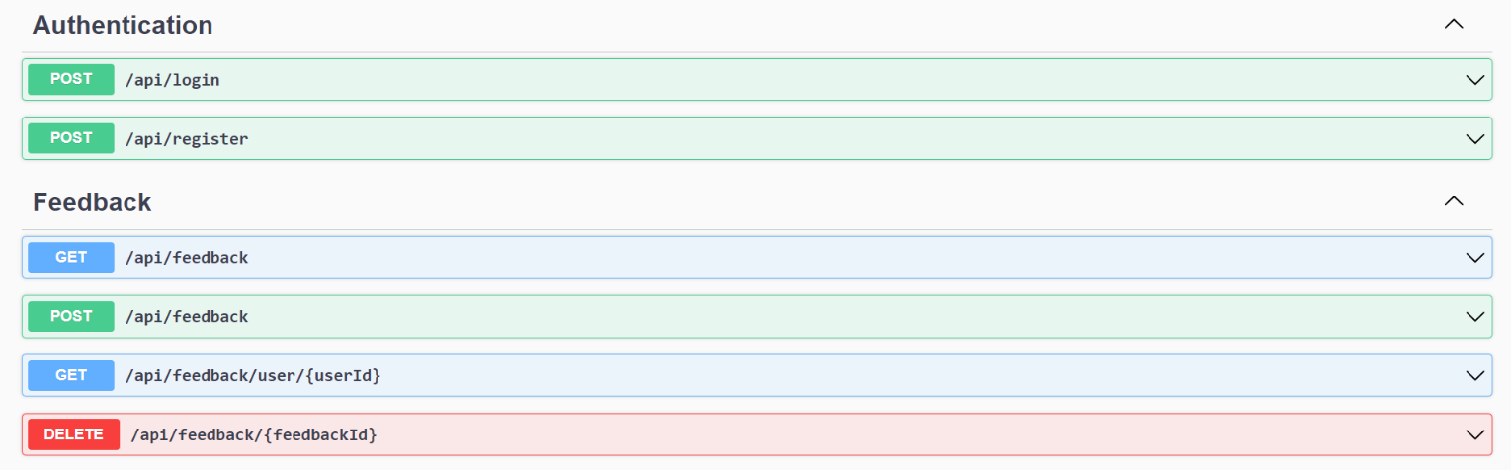

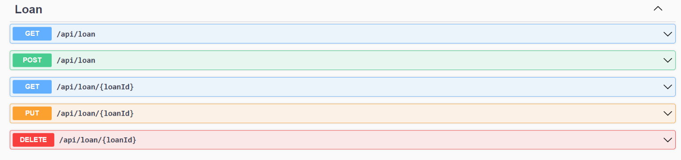

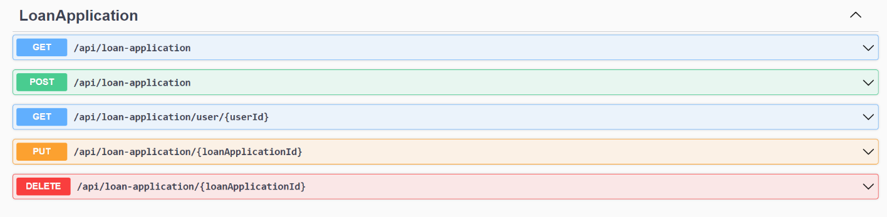

**1. Login: [Access for both Admin and User]**

**Endpoint name:** “/api/login”

**Method**: POST

**Request body**:

{

"Email": "string",

"Password": "string"

}

**Response:**

**2. Register: [Access for both Admin and User]**

**Endpoint name:** “/api/register”

**Method**: POST

**Request body:**

{

"Username": "string",

"Email": "user@example.com",

"MobileNumber": "9876541221",

"Password": "Pass@2425",

"UserRole": "string"

}

**Response:**

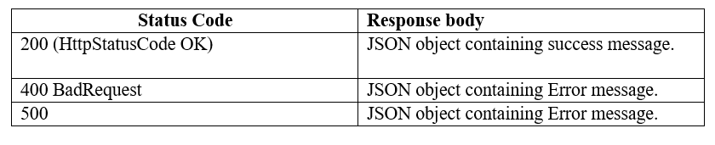

**3. Get all loans: [Access for both Admin and User]**

**Endpoint name:** “/api/loan”

**Method**: GET

**Response:**

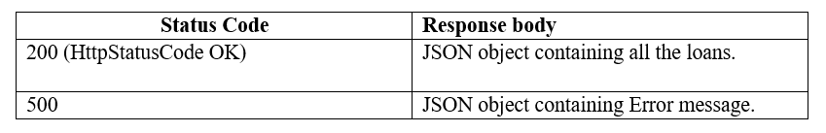

**4. Add loan: [Access for only Admin]**

**Endpoint name**: “/api/loan”

**Method**: POST

**Request body:**

{

"LoanType": "string",

"Description": "string",

"InterestRate": 10,

"MaximumAmount":10

}

**Response:**



**5. Get specific loan: [Access for only Admin]**

**Endpoint name**: “/api/loan/{loanId}”

**Method**: GET

**Parameter**: loanId

**Response**:

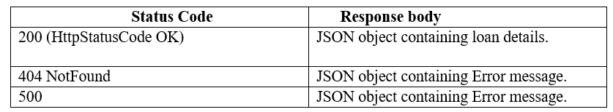

**6. Update loan: [Access for only Admin]**

**Endpoint name**: “/api/loan/{loanId}”

**Method**: PUT

**Parameter**: loanId

**Request body:**

{

"LoanType": "string",

"Description": "string",

"InterestRate": 10,

"MaximumAmount":10

}

**Response**:

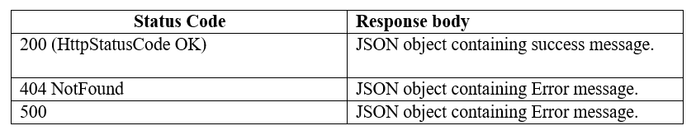

**7. Delete loan: [Access for only Admin]**

**Endpoint name**: “/api/loan/{loanId}”

**Method**: DELETE

**Parameter**: loanId

**Response:**

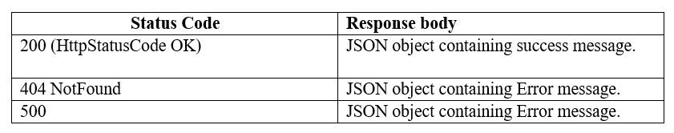

**8. Get all loan applications: [Access for only Admin]**

**Endpoint name**: “/api/loan-application”

**Method**: GET

**Response**:

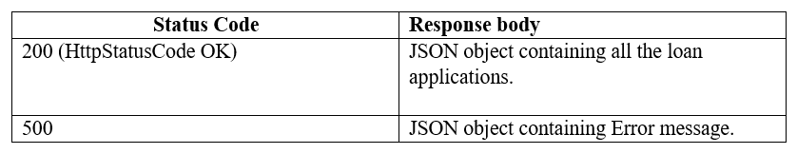

**9. Add loan application: [Access for only User]**

**Endpoint name**: “/api/loan-application”

**Method**: POST

**Request body**:

{

"UserId": 1,

"LoanId": 1,

"SubmissionDate": "2024-05-05T12:00:42.743Z",

"Income": 0,

"Model": "2024-05-05T12:00:42.743Z",

"PurchasePrice": 0,

"LoanStatus": 0,

"Address": "string",

"File": "string"

}

**Response**:



**10. Get loan application specific to user: [Access for only User]**

**Endpoint name**: “/api/loan-application/{userId }”

**Method**: GET

**Parameter**: userId

**Response**:

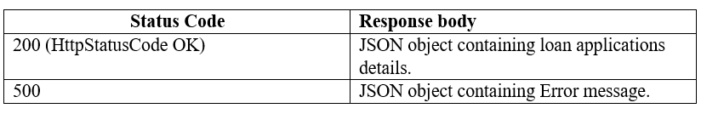

**11. Update loan application: [Access for both Admin and User]**

**Endpoint name**: “/api/loan-application/{loanApplicationId}”

**Method**: PUT

**Parameter**: loanApplicationId

**Request body**:

{

"UserId": 0,

"LoanId": 0,

"SubmissionDate": "2024-05-05T12:00:42.743Z",

"Income": 0,

"Model": "2024-05-05T12:00:42.743Z",

"PurchasePrice": 0,

"LoanStatus": 0,

"Address": "string",

"File": "string"

}

**Response**:

**12. Delete loan application: [Access for only User]**

**Endpoint name:** “/api/loan-application/{loanApplicationId}”

**Method**: DELETE

**Parameter**: loanApplicationId

**Response**:



**13. Get all feedbacks: [Access for only Admin]**

**Endpoint name**: “/api/feedback”

**Method**: GET

**Response**:

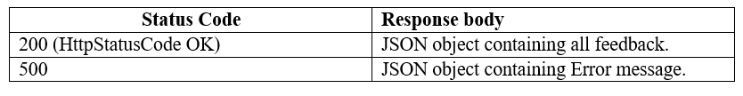

**14. Add feedback: [Access for only User]**

**Endpoint name**: “/api/feedback”

**Method**: POST

**Request body:**

{

"UserId": 0,

"FeedbackText": "string",

"Date": "2024-07-07T12:28:56.927Z"

}

**Response:**



**15. Get feedback specific to user: [Access for only User]**

**Endpoint name**: “/api/feedback/{userId }”

**Method**: GET

**Parameter**: userId

**Response**:

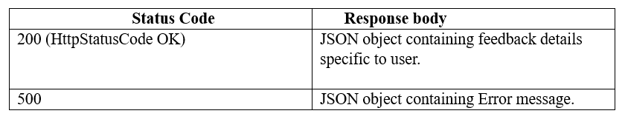

**16. Delete feedback: [Access for only User]**

**Endpoint nam**e: “/api/feedback /{feedbackId}”

**Method**: DELETE

**Parameter**: feedbackId

**Response**:



**Frontend Requirements:**

* Create a folder named components inside the app to store all the components. (Refer project structure screenshots).
* Create a folder named models inside app to store all the model interface.
* Create a folder named as services inside app to implement all the services.
* Create model interface referring the backend entities (User, Loan, Loanapplication, Feedback) mentioned in the backend requirements accordingly.
* You can create your own components based on the application requirements.
* Import model files, services and components as required.

**Project Folder Screenshot:**

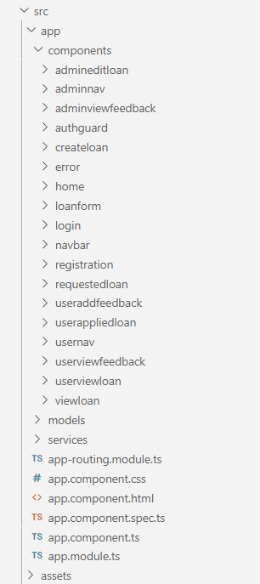

Services and Models:

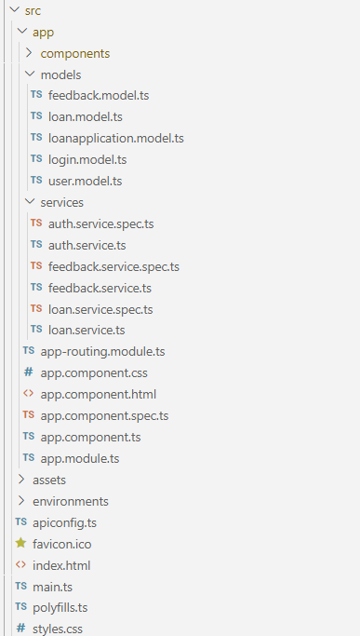

**Frontend Models:**

**User Model:**

class User {

UserId?: number;

Email: string;

Password: string;

Username: string;

MobileNumber: string;

UserRole: string;

}

**Login Model:**

class Login {

Email: string;

Password: string;

}

**LoanApplication Model:**

interface LoanApplication {

LoanApplicationId?: number;

UserId?: number;

UserName: string;

LoanId?: number;

SubmissionDate: String;

Income: number;

Model: string;

PurchasePrice: number;

LoanStatus: number;

Address: string;

File: string;

}

**Loan Model:**

interface Loan {

LoanId?:number;

LoanType: string;

Description: string;

InterestRate: number;

MaximumAmount: number;

}

**Feedback Model:**

class Feedback {

FeedbackId?: number;

UserId: number;

FeedbackText: string;

Date: Date;

}

**Frontend services:**

* Declare a public property apiUrl to store the backend URL in all the services.
* For example, public apiUrl = 'http://localhost:8080'. Instead of 'localhost', replace it with the URL of your workspace port 8080 URL.
* For the API’s to be used please refer the API Table.
* Authorized token to be passed in headers for all end points.

**1. AuthService(auth.service.ts)**:

* Create a service name as **auth** inside app/services folder to implement the following functions.

Methods Overview:

* register(user: User): Observable<any>:
* Use this method to register a new user. It sends a POST request to the '/api/register' endpoint with the user data provided as the body.
* login(login : Login): Observable<any>:
* This method is used to authenticate a user by logging them in. It sends a POST request to the '/api/login' endpoint with the user's email and password. Upon successful login, it stores the JWT token in localStorage and updates the user's role and ID using BehaviorSubjects.

**2. LoanService(loan.service.ts):**

* Create a service name as **loan** inside app/services and implement the following functions in it.

Methods Overview:

* getAllLoans(): Observable<Loan[]>:
* Use this method to fetch all loans from the server. It sends a GET request to the '/api/loan' endpoint with the authorization token prefixed with 'Bearer' stored in localStorage.
* deleteLoan(loanId: string): Observable<void>:
* Call this method to delete a loan with the specified ID. It sends a DELETE request to the '/api/loan/:id' endpoint with the loan ID and the authorization token prefixed with 'Bearer' stored in localStorage.
* getLoanById(id: string): Observable<Loan>:
* Use this method to retrieve a loan by its ID. It sends a GET request to the '/api/loan/:id' endpoint with the loan ID and the authorization token prefixed with 'Bearer' stored in localStorage.
* addLoan(requestObject: Loan): Observable<Loan>:
* Call this method to add a new loan. It sends a POST request to the '/api/loan' endpoint with the loan data provided as the requestObject and the authorization token prefixed with 'Bearer' stored in localStorage.
* updateLoan(id: string, requestObject: Loan): Observable<Loan>:
* Use this method to update an existing loan. It sends a PUT request to the '/api/loan/:id' endpoint with the loan ID and the updated loan data provided as the requestObject, along with the authorization token prefixed with 'Bearer' stored in localStorage.
* getAppliedLoans(userId: string): Observable<LoanApplication[]>:
* This method retrieves all loan applications submitted by a specific user. It sends a GET request to the '/api/loan-application/user/:userId' endpoint with the user ID and the authorization token prefixed with 'Bearer' stored in localStorage.
* deleteLoanApplication(loanId: string): Observable<void>:
* Call this method to delete a loan application with the specified ID. It sends a DELETE request to the '/api/loan-application/:id' endpoint with the loan application ID and the authorization token prefixed with 'Bearer' stored in localStorage.
* addLoanApplication(data: LoanApplication): Observable<LoanApplication>:
* Use this method to submit a new loan application. It sends a POST request to the '/api/loan-application' endpoint with the loan application data provided as the data parameter and the authorization token prefixed with 'Bearer' stored in localStorage.
* getAllLoanApplications(): Observable<LoanApplication[]>:
* This method fetches all loan applications from the server. It sends a GET request to the '/api/loan-application' endpoint with the authorization token prefixed with 'Bearer' stored in localStorage.
* updateLoanStatus(id: string, loanApplication: LoanApplication): Observable<LoanApplication>:
* Call this method to update the status of a loan application. It sends a PUT request to the '/api/loan-application/:id' endpoint with the loan application ID, updated loan application data, and the authorization token prefixed with 'Bearer' stored in localStorage.

**3. FeedbackServic(feedback.service.ts):**

* Create a service name as **feedback** inside app/services and implement the following functions in it.

Methods Overview:

* sendFeedback(feedback: Feedback): Observable<Feedback>:
* Use this method to send feedback to the server. It sends a POST request to the '/api/feedback' endpoint with the feedback data provided and the authorization token prefixed with 'Bearer' stored in localStorage.
* getAllFeedbacksByUserId(userId: string): Observable<Feedback[]>:
* This method retrieves all feedbacks submitted by a specific user. It sends a GET request to the '/api/feedback/user/:userId' endpoint with the user ID and the authorization token prefixed with 'Bearer' stored in localStorage.
* deleteFeedback(feedbackId: string): Observable<void>:
* Call this method to delete a feedback with the specified ID. It sends a DELETE request to the '/api/feedback/:feedbackId' endpoint with the feedback ID and the authorization token prefixed with 'Bearer' stored in localStorage.
* getFeedbacks(): Observable<Feedback[]>:
* This method fetches all feedbacks from the server. It sends a GET request to the '/api/feedback' endpoint with the authorization token prefixed with 'Bearer' stored in localStorage.

**Validations:**

**Client-Side Validation:**

* Implement client-side validation using HTML5 attributes and JavaScript to validate user input before making API requests.
* Provide immediate feedback to users for invalid input, such as displaying error messages near the input fields.

**Server-Side Validation:**

* Implement server-side validation in the controllers to ensure data integrity.
* Validate user input and API responses to prevent unexpected or malicious data from affecting the application.
* Return appropriate validation error messages to the user interface for any validation failures.

**Exception Handling:**

* Implement exception handling mechanisms in the controllers to gracefully handle errors and exceptions. Define custom exception classes for different error scenarios, such as API communication errors or database errors.
* Log exceptions for debugging purposes while presenting user-friendly error messages to users. Record all the exceptions and errors handled store in separate table “ErrorLogs”.

**Error Pages:**

**Create custom error pages for different HTTP status codes (e.g., 404 Not Found, 500 Internal Server Error) to provide a consistent and user-friendly error experience. Ensure that error pages contain helpful information and guidance for users.**

**Thus, create a reliable and user-friendly web application that not only meets user expectations but also provides a robust and secure experience, even when faced with unexpected situations. Error page has to be displayed if something goes wrong.**

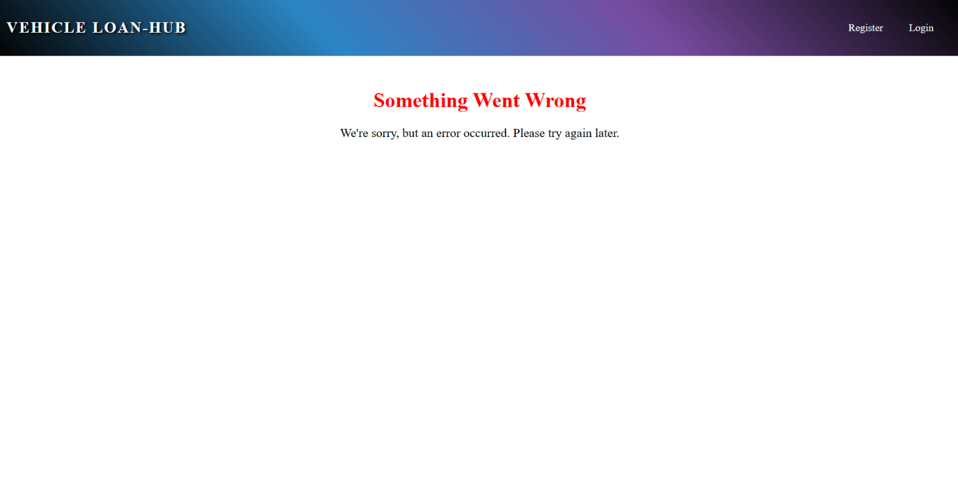

**Frontend Screenshots:**

**• All the asterisk (*) marked fields are mandatory in the form. Make sure to mark all the field names with * symbol followed by the validations.**

**Navigation Bar:**

(**navbar component**)



Component displays a title along with router links to "Register" and "Login".

**Landing Page:**

(**home component**)

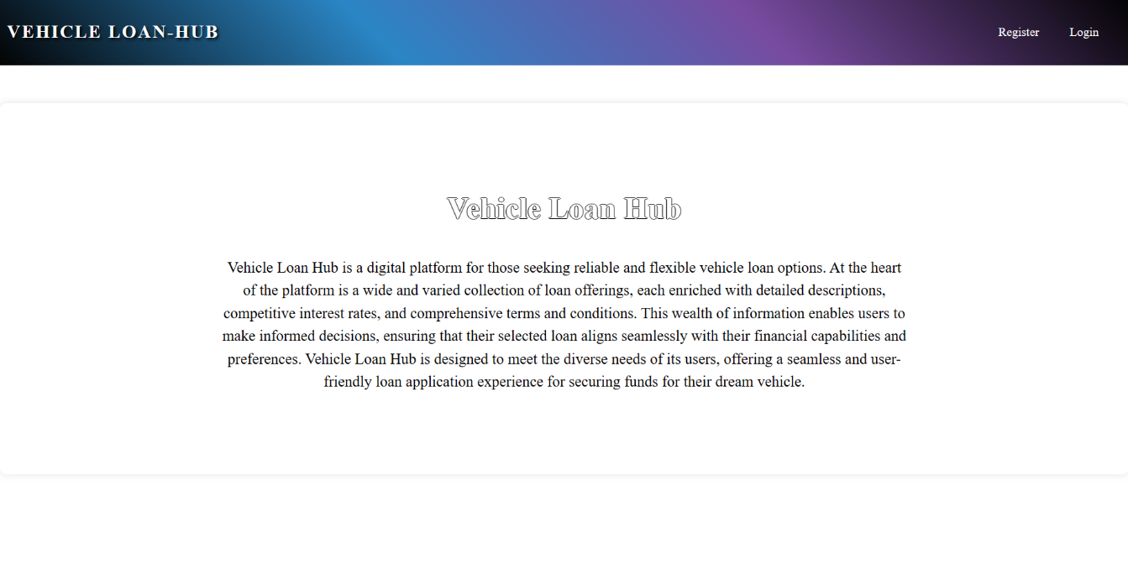

Component features a heading "Vehicle Loan Hub" accompanied by an introductory message that provides an overview of the application.

**User side (Admin and User):**

**Registration Page**:

(**registration component**)

Clicking "Register" in the navbar displays the registration page for both roles. Please refer to the screenshots below for validations.

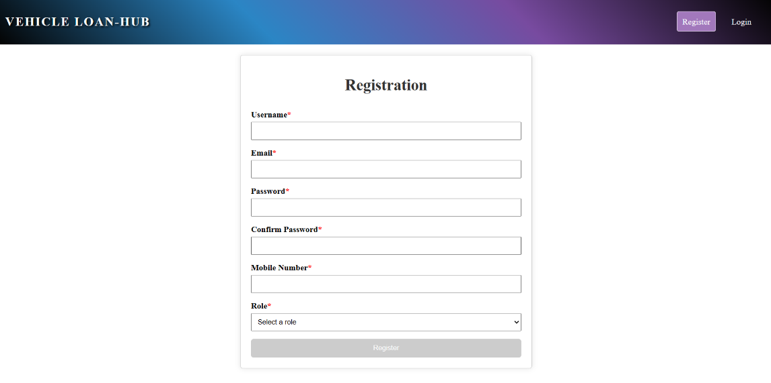

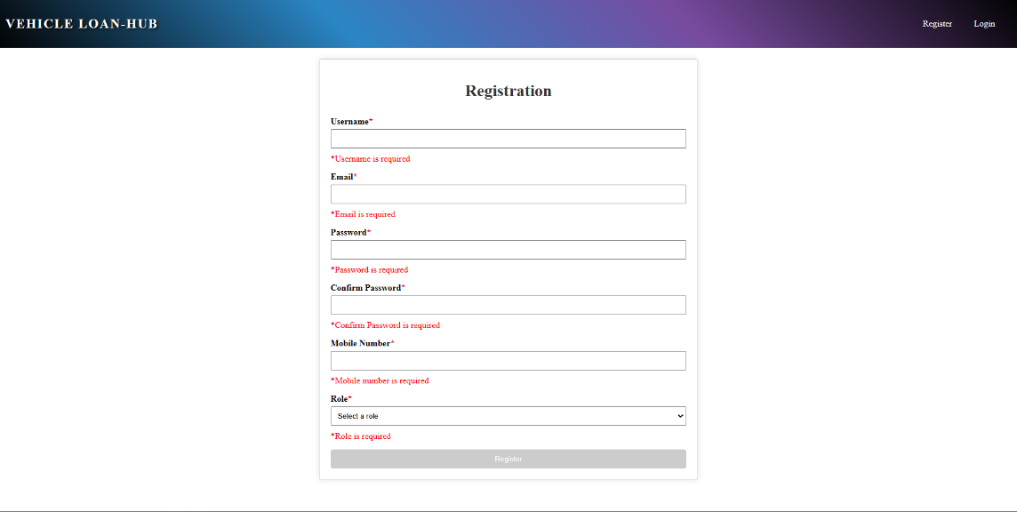

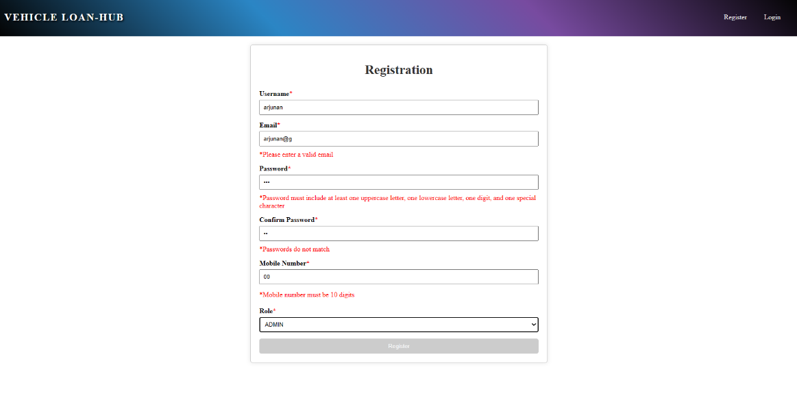

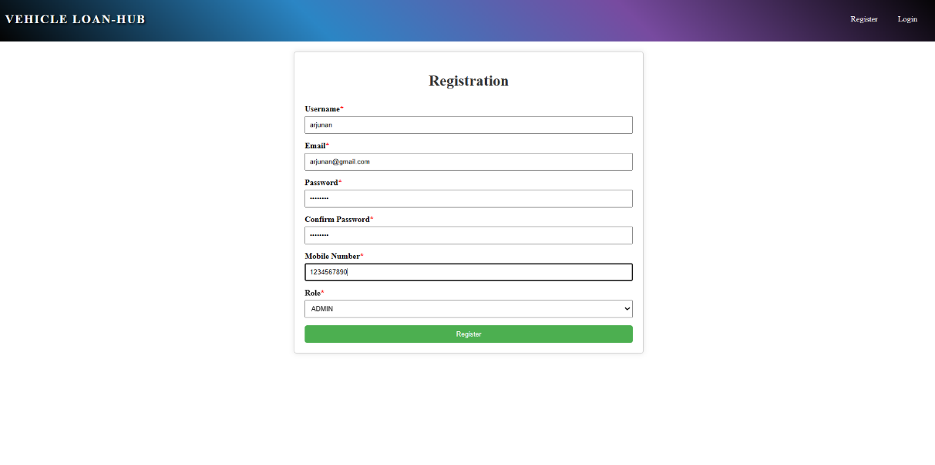

When the "Register" button is clicked, upon successful submission, the user must be navigated to the login page.

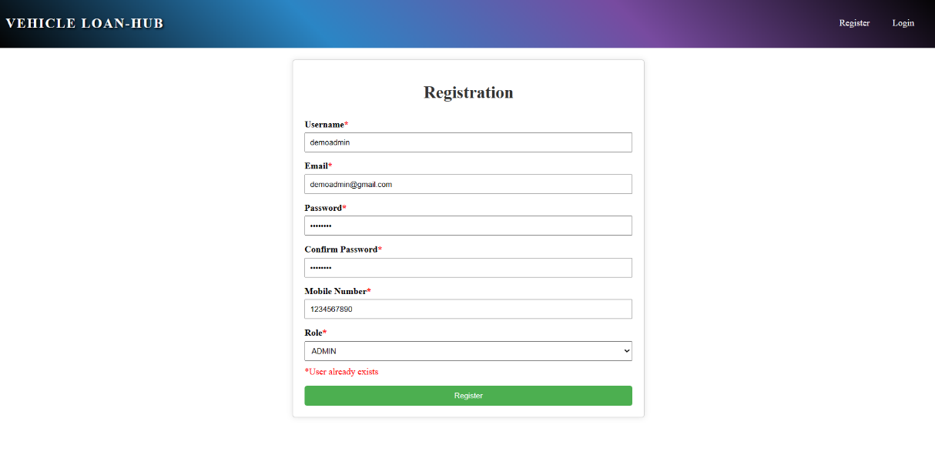

If a user attempts to register with an existing email, a message stating "User already exists" will be displayed.

**Login Page**

(**login component**)

This page is used for logging in to the application. On providing the valid email and password, the user will be logged in.

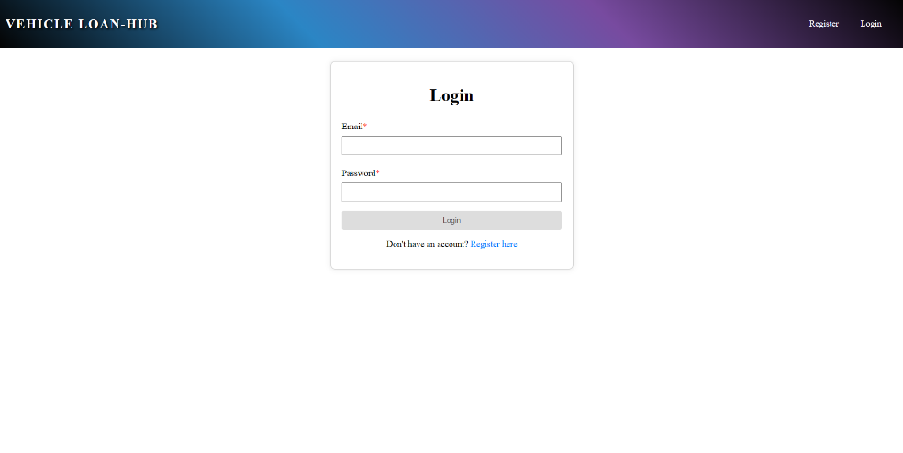

Perform validations for email and password fields.

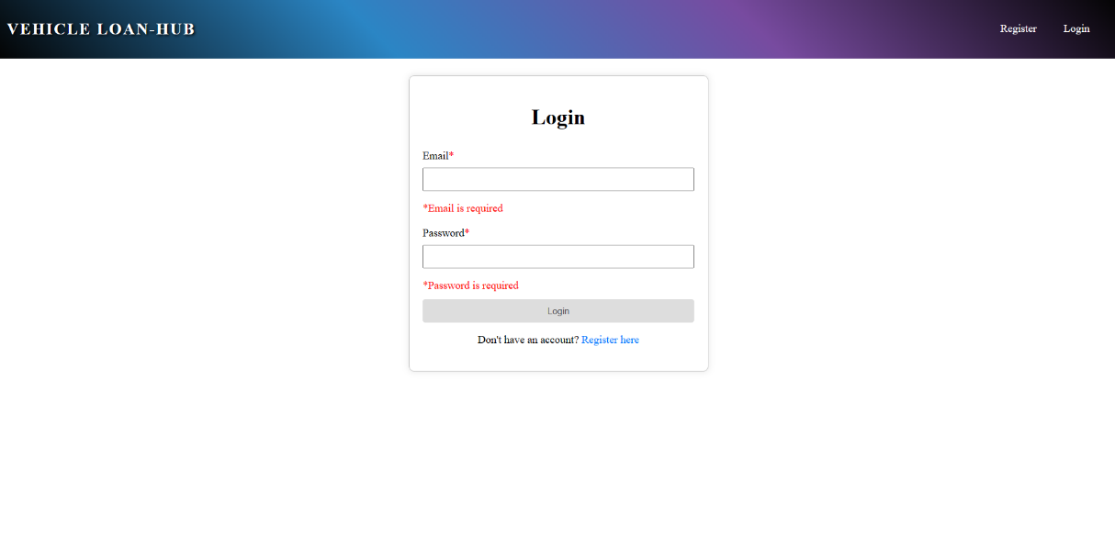

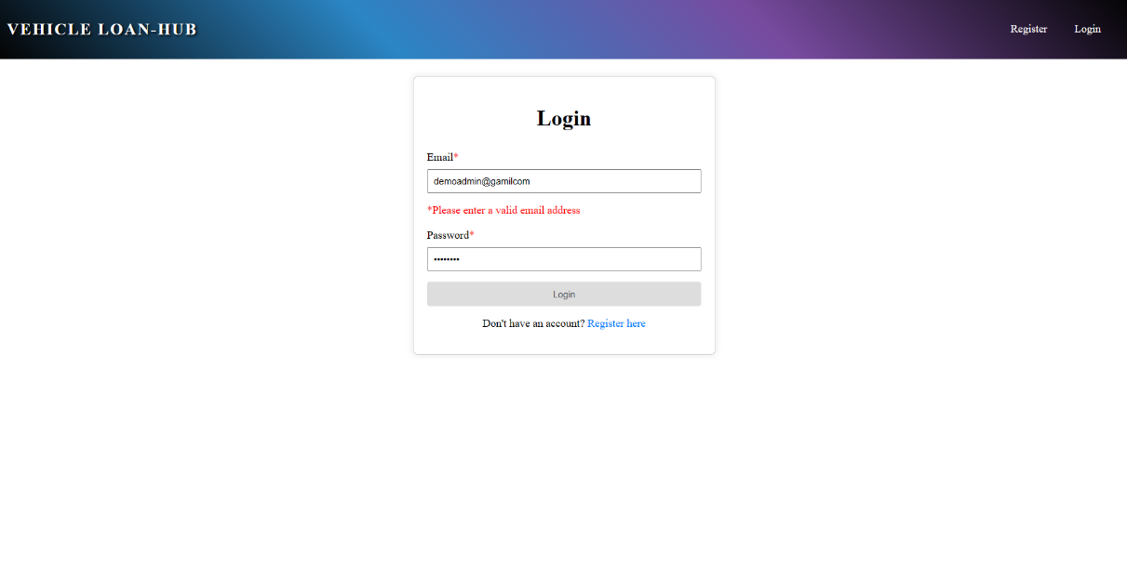

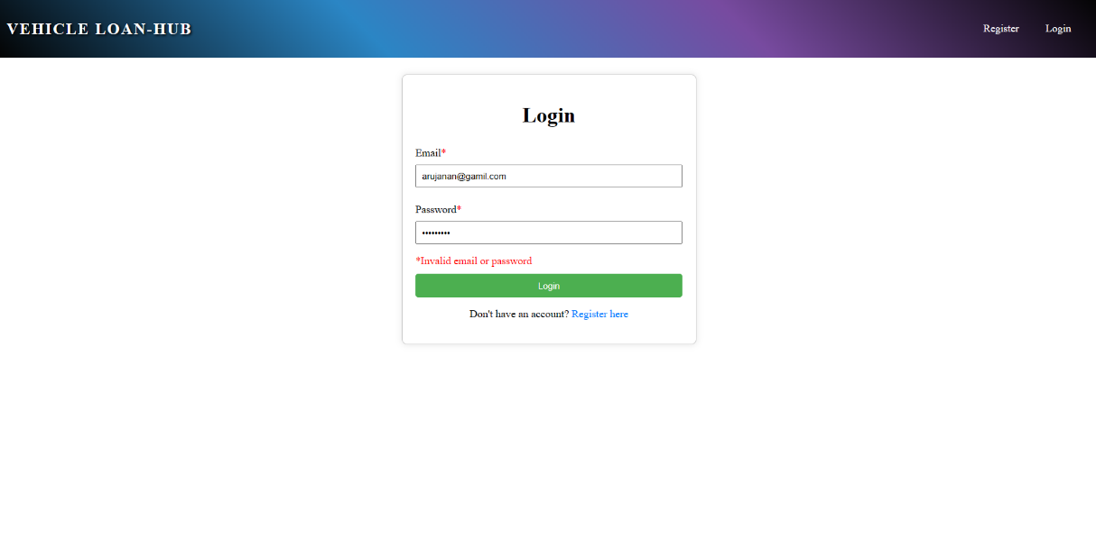

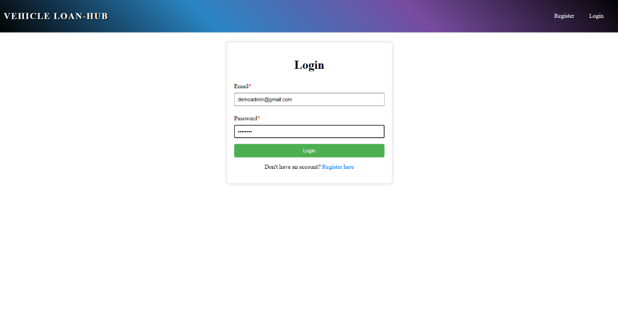

On Clicking the ‘Login’ button, user will be navigated to the (adminnav) based on their roles.

**Admin side:**

**Home Component:** This page is used to display the information about the loan hub application. On clicking the ‘**Home**’ tab, user can view the information about the application.

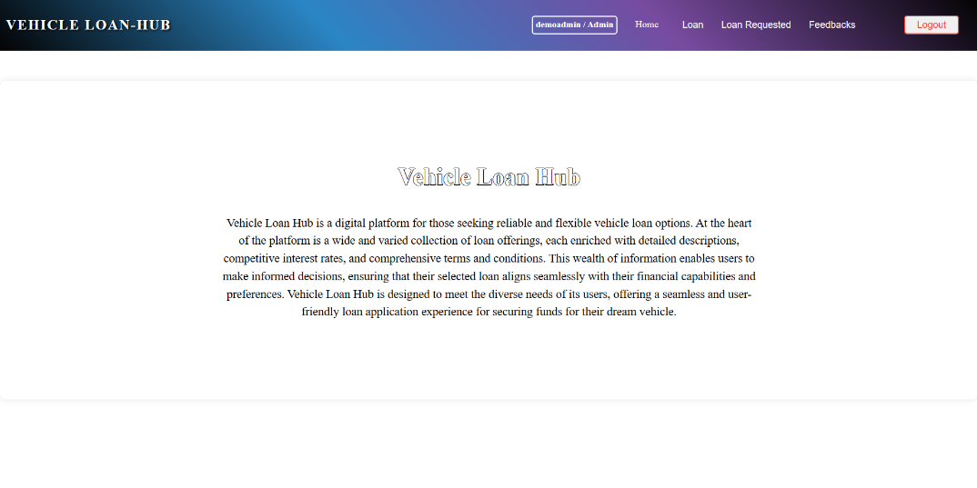

Upon successful login, if the user is an admin, the **(adminnav component)** will be displayed. If the user is a regular user, the **(usernav component)** will be displayed. Additionally, the role-based navigation bar will also display login information such as the username and roleA screenshot of a computer

Admins can navigate to other pages by clicking on the menu available in the navigation bar.

On hovering over the "Loan" item in the navbar, a submenu should appear with options to "Add Loan" and "View Loan".

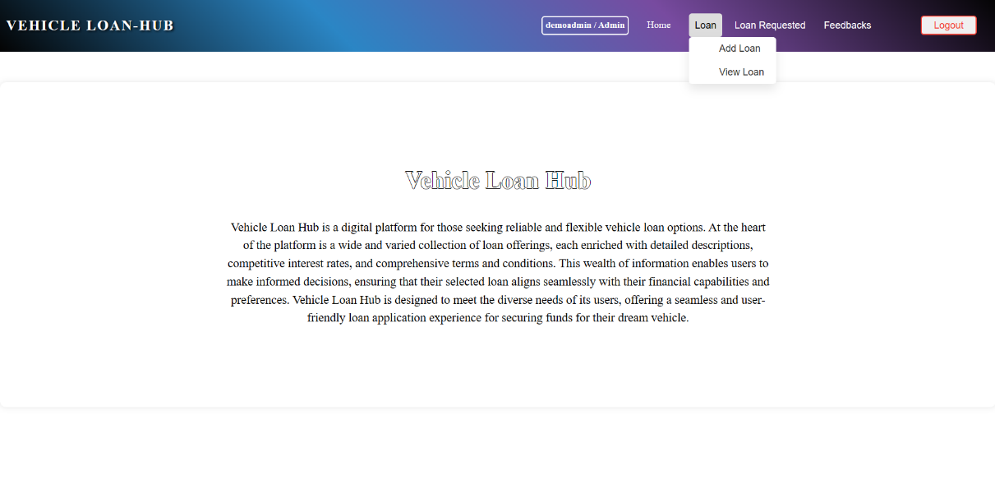

Clicking on "Add Loan" will navigate to the **createloan component**, which displays a form with the heading "**Create New Loan**". The admin should be able to add the loan details on this page, which is used to add a new loan to the system.

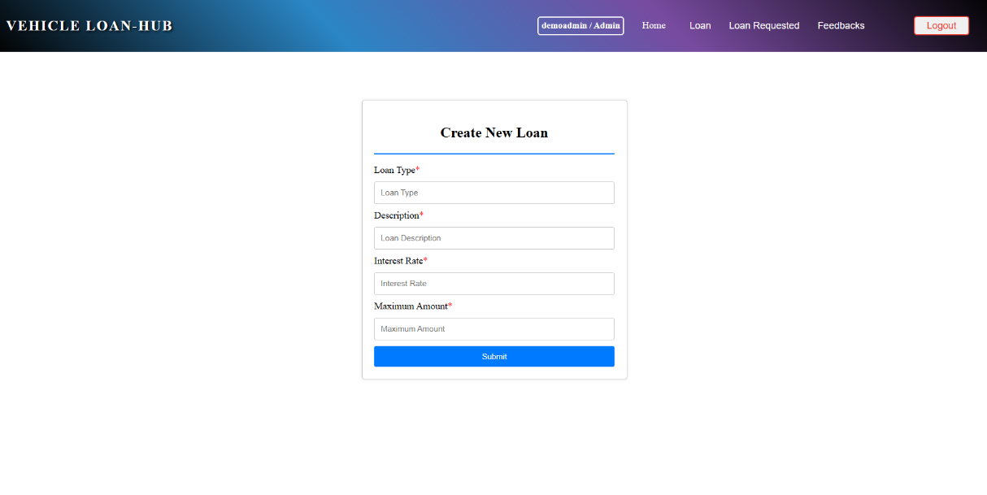

Perform validations for all the form fields.

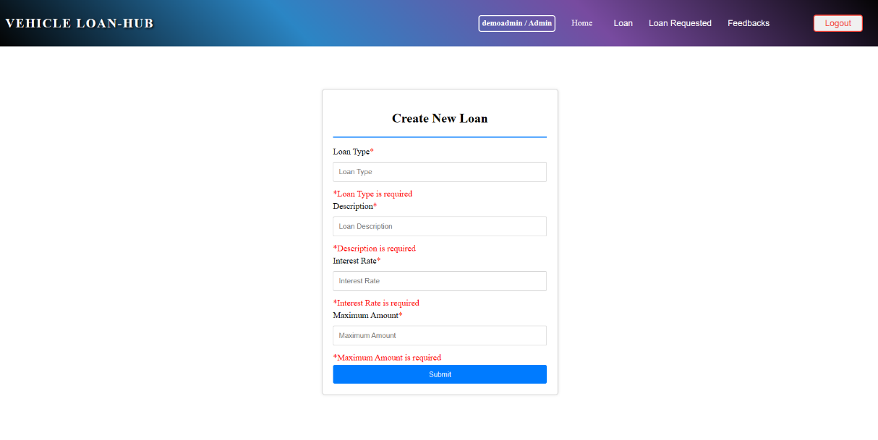

Clicking the "Submit" button with empty fields will display a validation message stating "All fields are required".

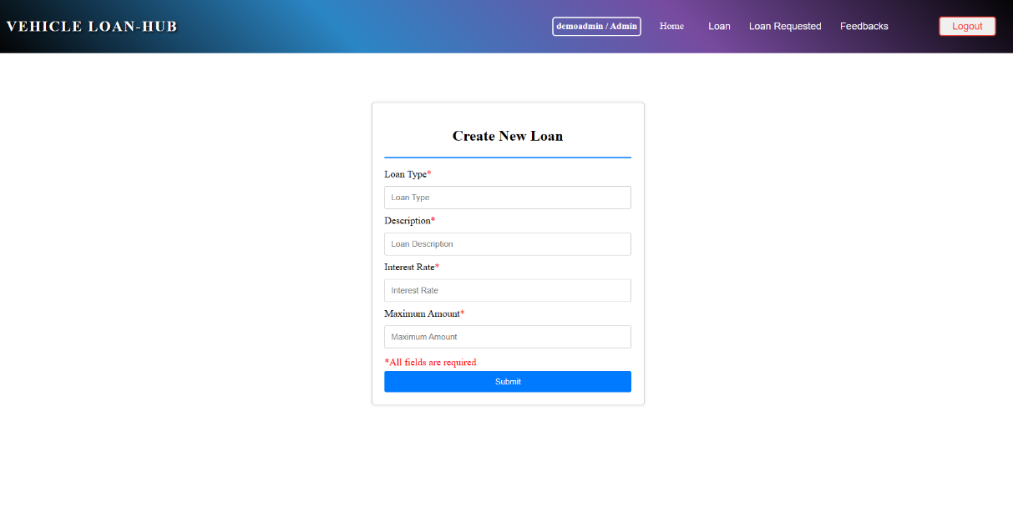

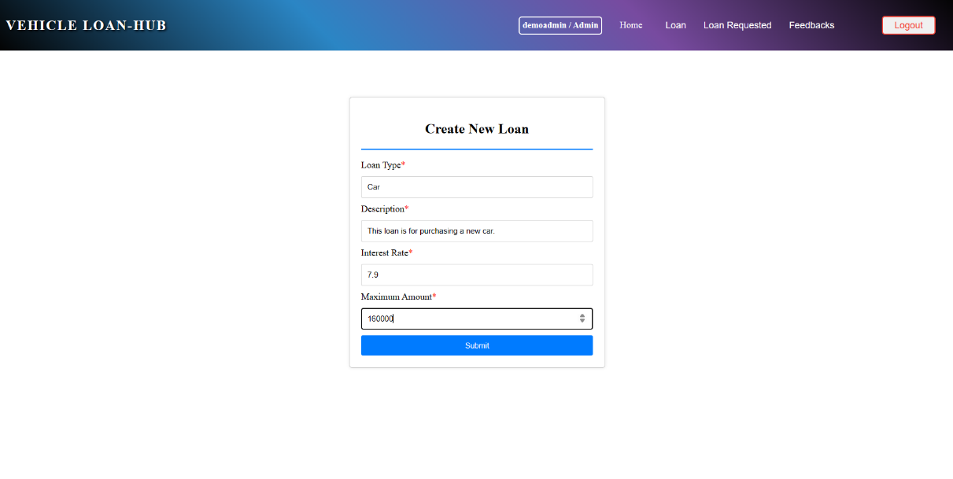

Upon clicking the "Submit" button, if the operation is successful, a popup message saying "Successfully Added!" should be displayed.

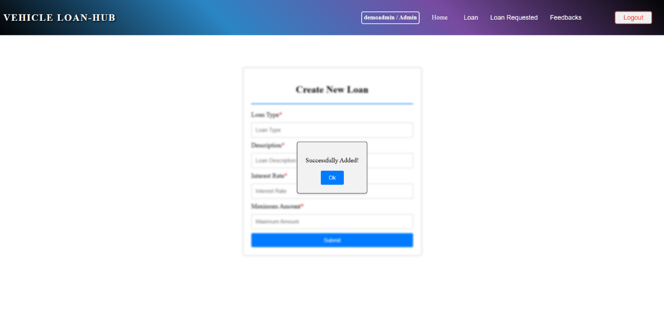

If the admin adds a new loan with an existing loan type, an error message stating "Loan with the same type already exists" should be displayed.

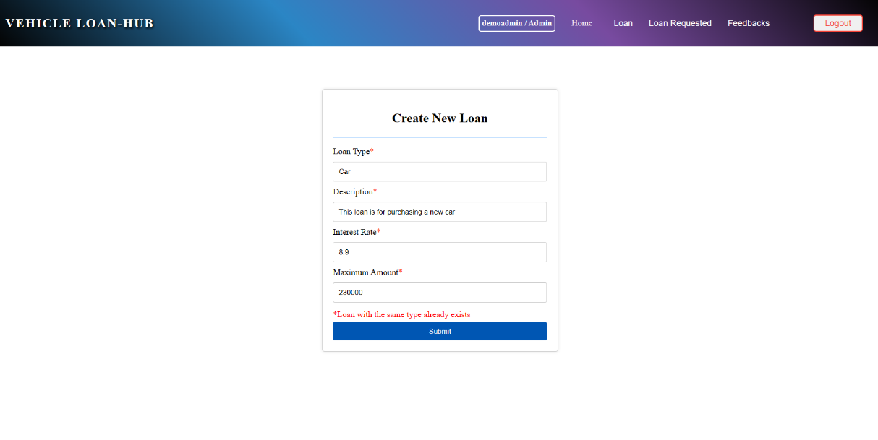

On Clicking the ‘Submit’ button a loan is added to the system and admin can add a new loan again. To move to other pages admin can click any of the menus available in the navbar.

**Admin View Loan**

On hovering over the "Loan" item in the navbar, a submenu should appear with options to "Add Loan" and "View Loan".

Clicking on "View Loan" will navigate to the **viewloan component**, which displays all loan details in a table format with the heading "Vehicle Loans". Additionally, a search feature is provided to search based on LoanType and Description.

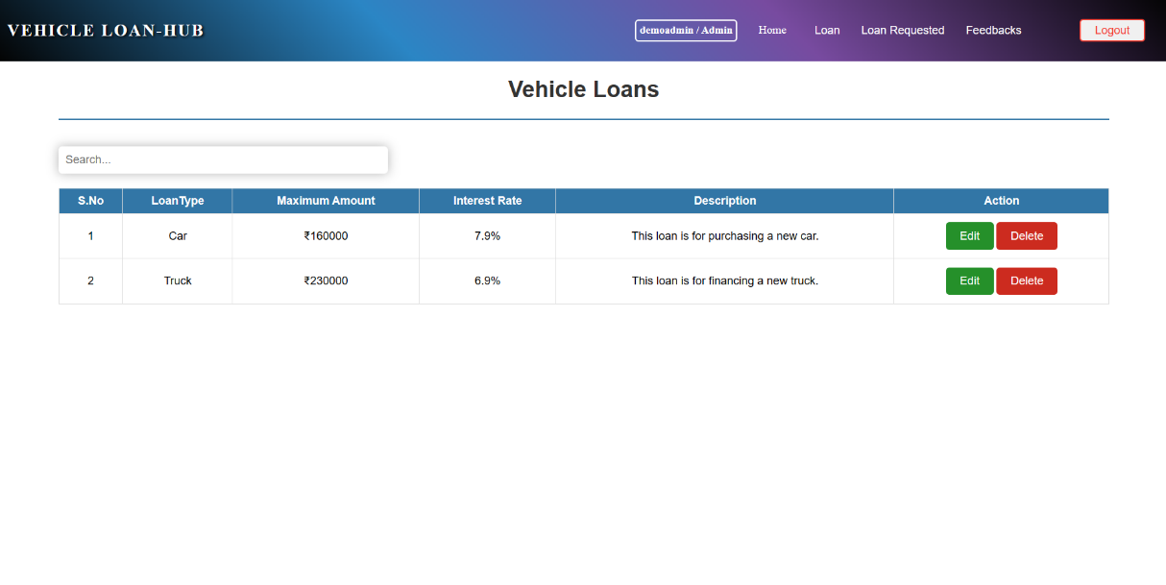

Clicking the edit button will navigate to the **admineditloan component**, which displays an editing form with pre-populated loan data of the selected loan. This form also contains a "Back" button that will navigate to the **viewloan component**. Validations are performed for all the form fields.

If the Admin updates the loan type to match an existing loan type, an error indicating "Loan with the same type already exists" will be displayed.

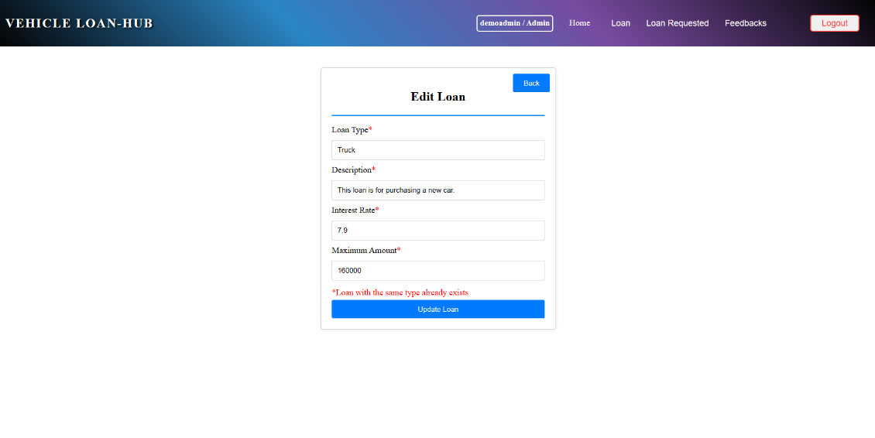

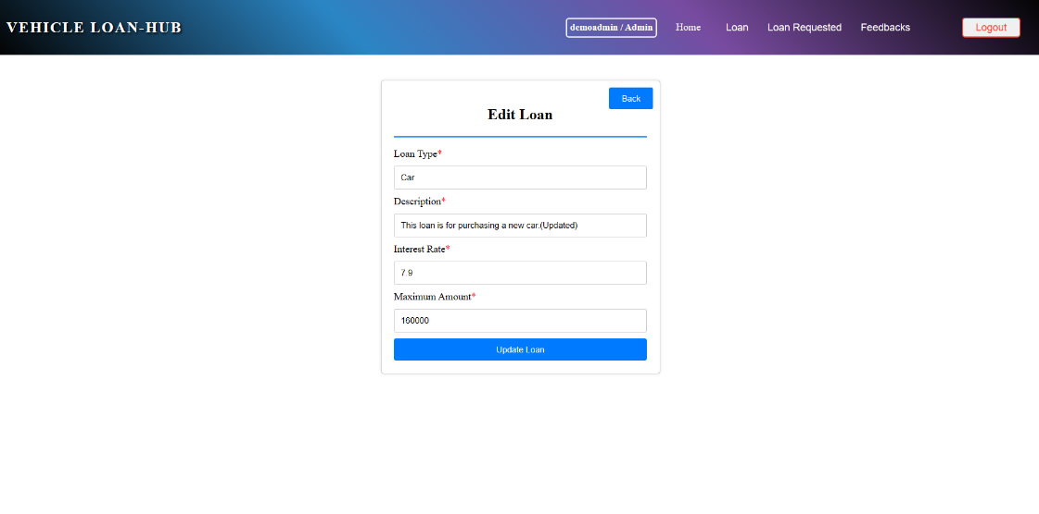

Upon clicking the "Update Loan" button, if the operation is successful, a popup saying "Updated successfully" will be displayed. Clicking "OK" will redirect to the viewloan component.

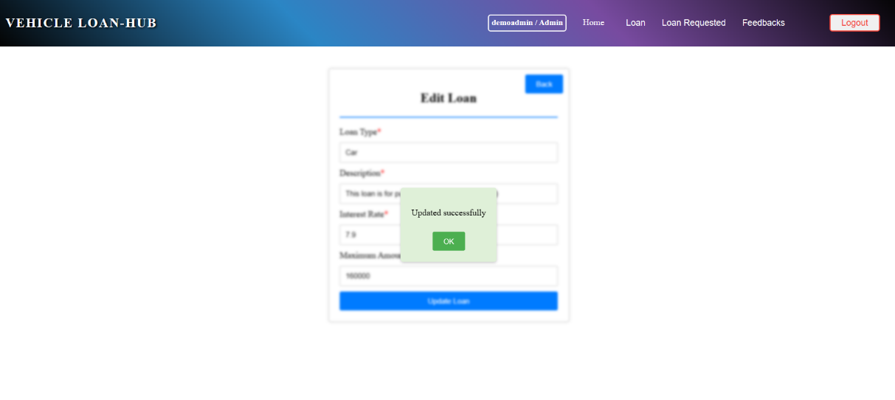

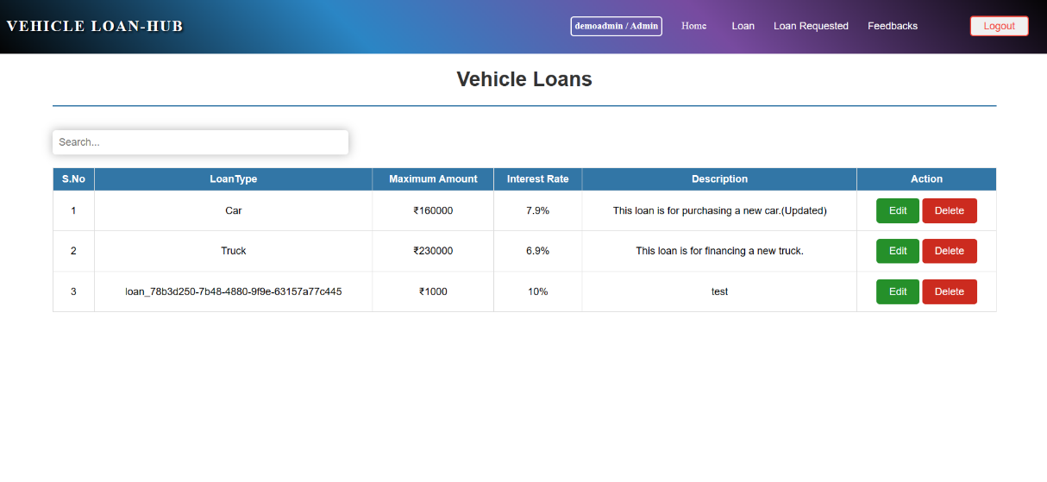

On clicking the "Delete" button, a pop-up should be displayed with confirmatory message to delete the data.

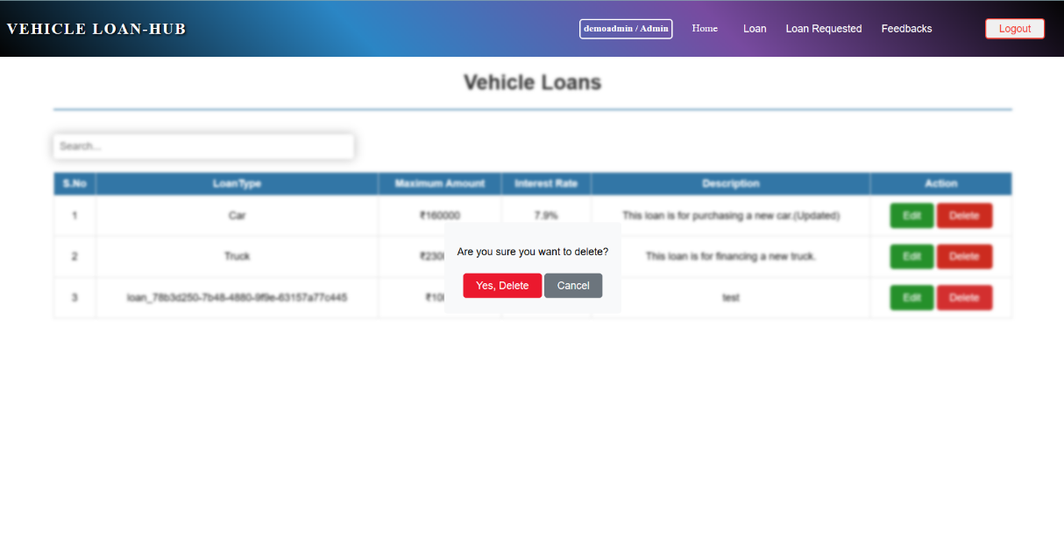

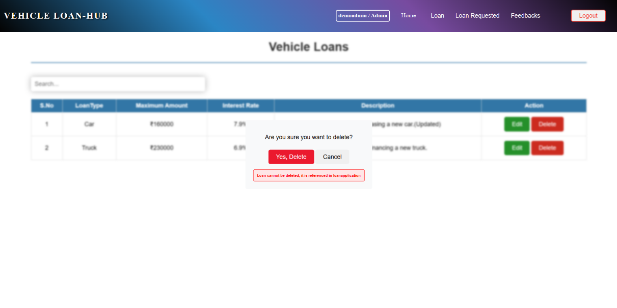

Once a user has applied for the loan, the admin should not be able to delete the loan. Attempting to do so will display an error message stating "Loan cannot be deleted, it is referenced in loan application".

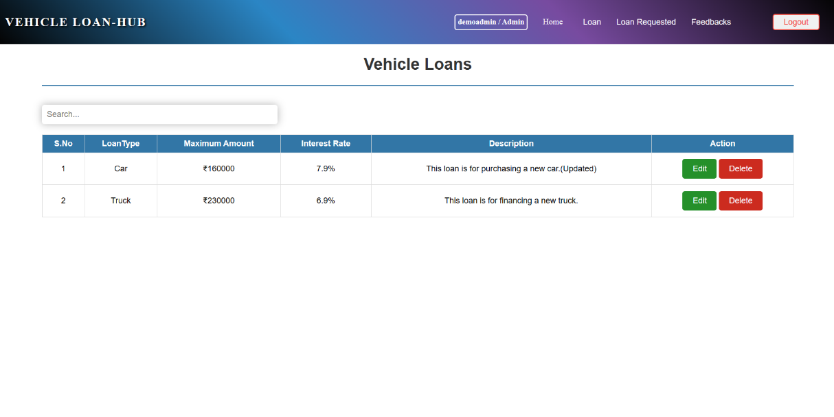

After successful deletion, the table should be refreshed as mentioned in the above images.

**Admin View Loan Requested**

Clicking on "Loan Requested" from the navbar will navigate to the **requestedloan component**, which displays all loans requested by all users.

If no data is available, then "Oops! No records Found" should be displayed.

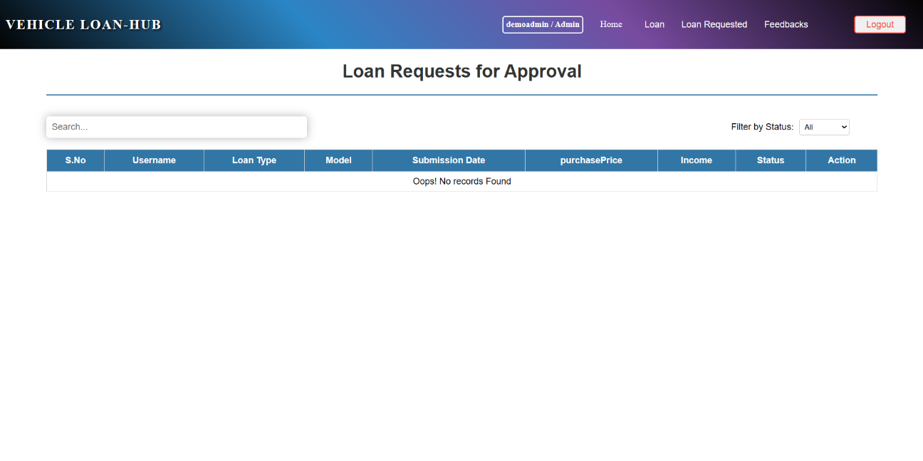

If data is available, the loans requested by all users will be displayed in table format. Additionally, features such as the admin being able to search based on Loan Type and filter the data based on Status.

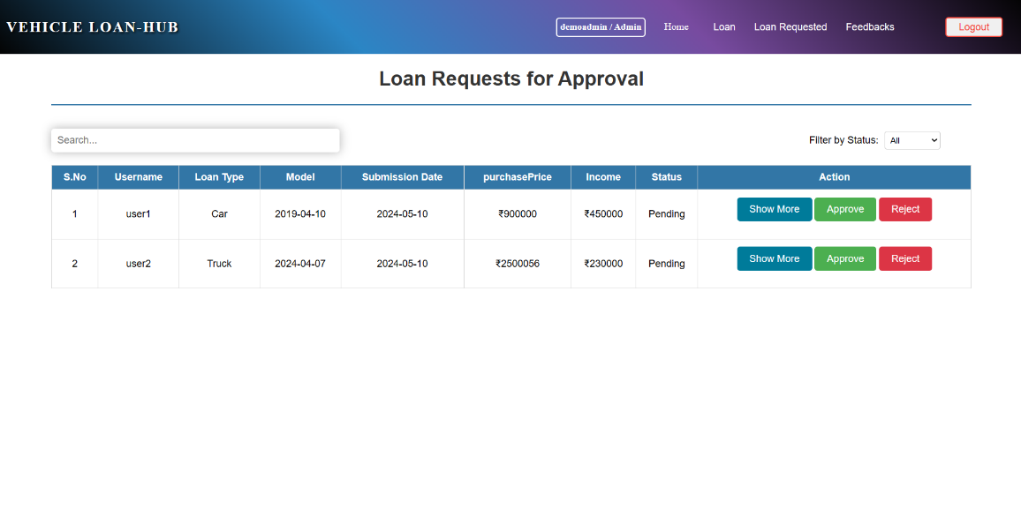

The admin can approve or reject user requests by clicking on the "Approve" or "Reject" button, respectively.

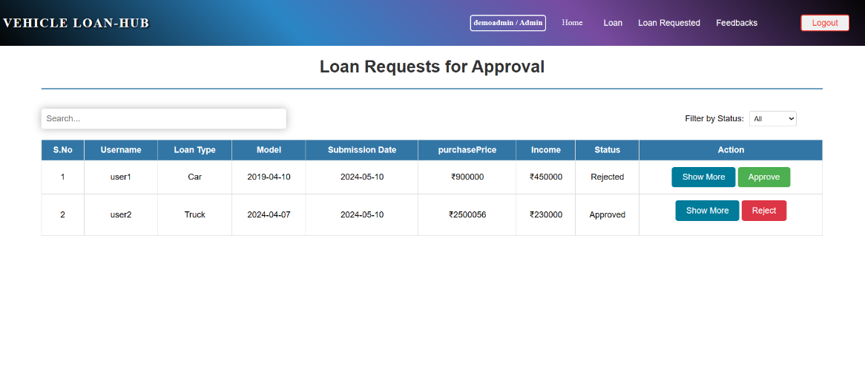

Clicking on "Show More" will display additional details such as Address and Proof in a popup modal.

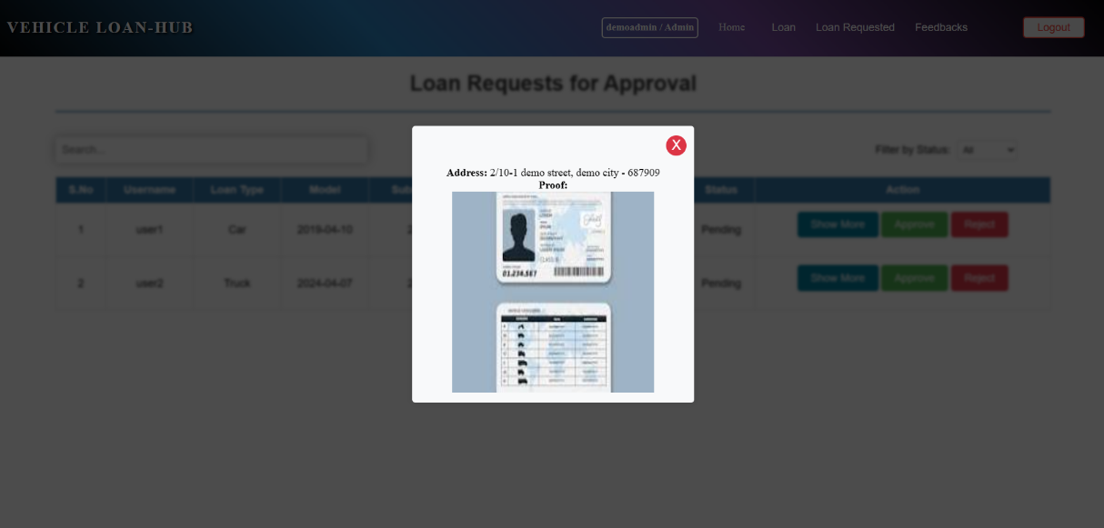

Clicking on the "X" sign will close the modal.

**Admin View Feedbacks:**

Clicking on "Feedbacks" from the navbar will navigate to the **adminviewfeedback component**, which displays all feedbacks posted by all users.

If no data is available, then "No data found" should be displayed.

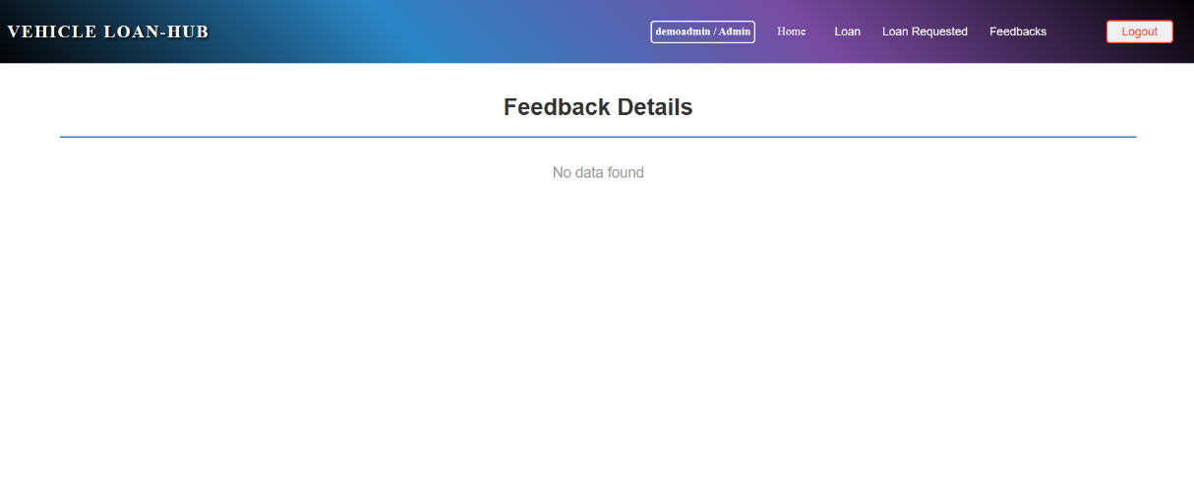

If data is available, the feedbacks posted by all users will be displayed in table format.

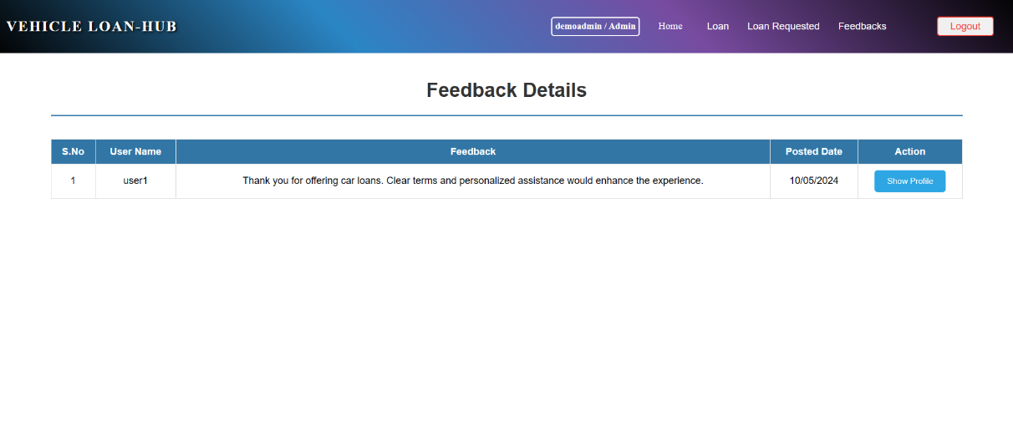

Clicking on "Show Profile" will display additional details about the user in pop-up modal.

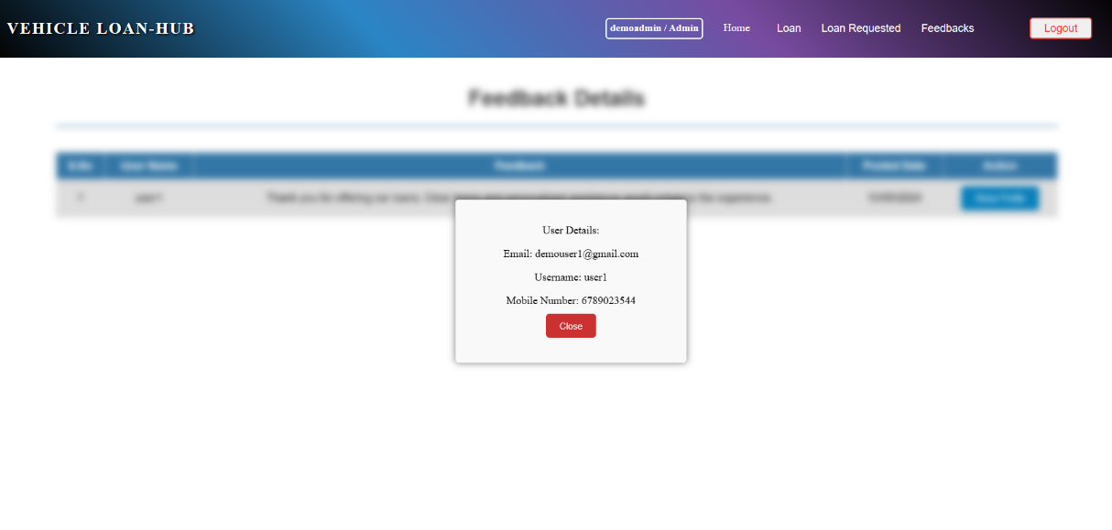

On clicking the "Close" button, will close the pop-up modal displayed.

On clicking the "Logout" button, a pop-up should be displayed with confirmatory message to logout the user.

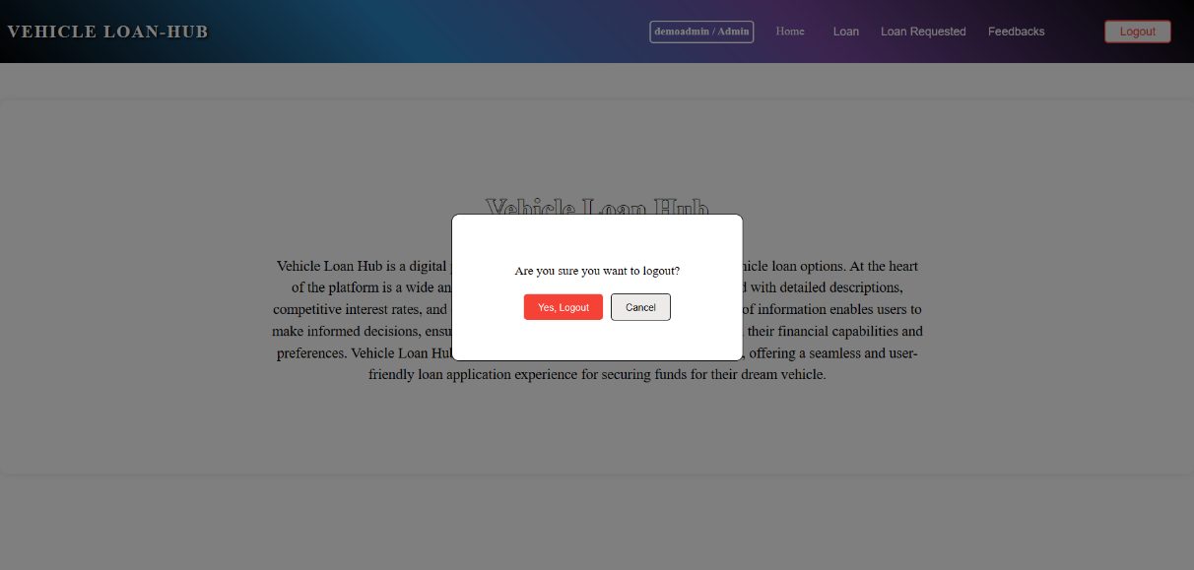

Clicking "Yes, Logout" will navigate to the login component.

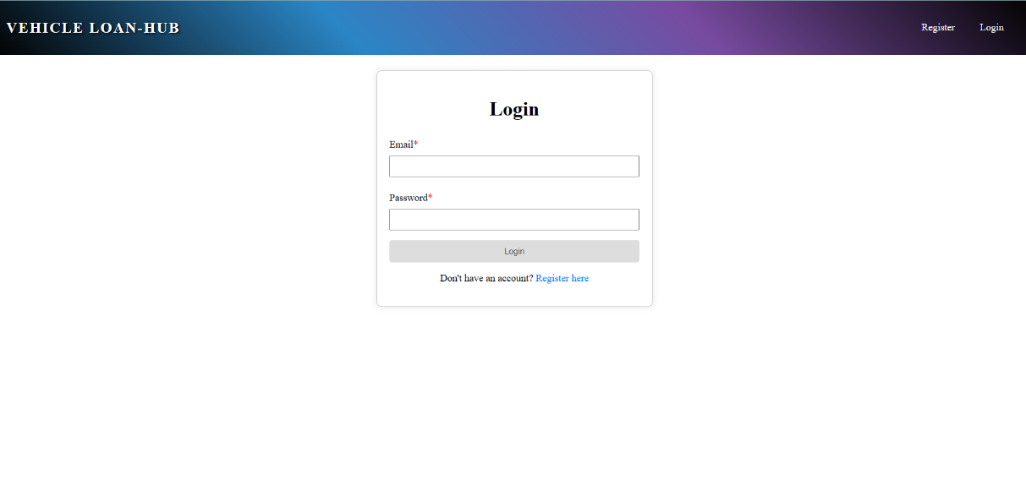

**User side:**

Home Component: This page is used to display the information about the loan hub application. On clicking the ‘Home’ tab, user can view the information about the application.

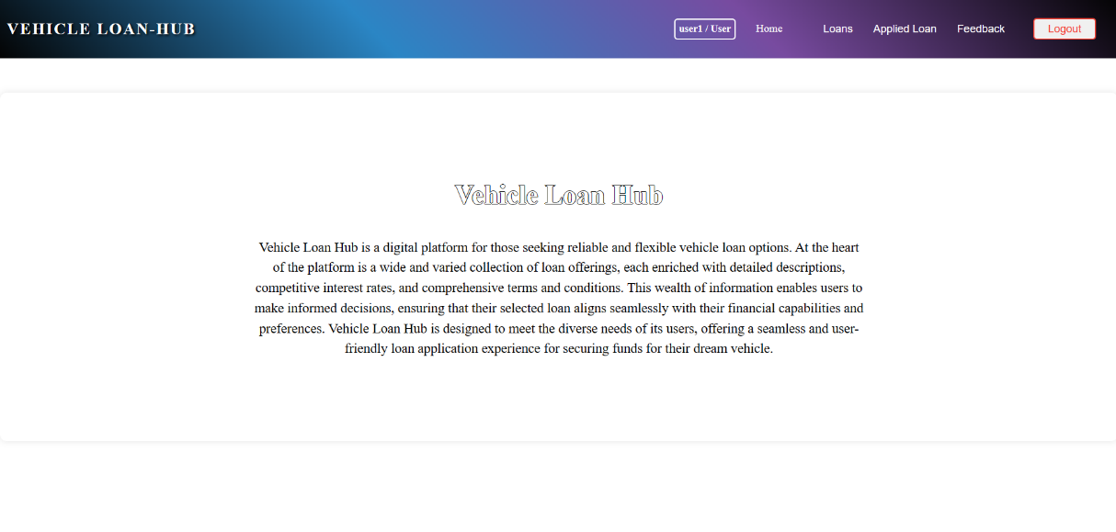

Upon successful login, if the user is an admin, the **(adminnav component)** will be displayed. If the user is a regular user, the **(usernav component)** will be displayed. Additionally, the role-based navigation bar will also display login information such as the username and role.

**User View Loans:**

Clicking on "Loans" from the navbar will navigate to the **userviewloan component**, which displays all loans posted by admin.

If no data is available, then "Oops! No records Found" should be displayed.

If the user has applied for the loan, it will display as "Applied"; otherwise, it will display "Apply".

Clicking the "Apply" button will navigate to the loanform component, which displays a form with the heading "Loan Application Form". Additionally, it includes a "Back" button, which, when clicked, moves back to the userviewloan component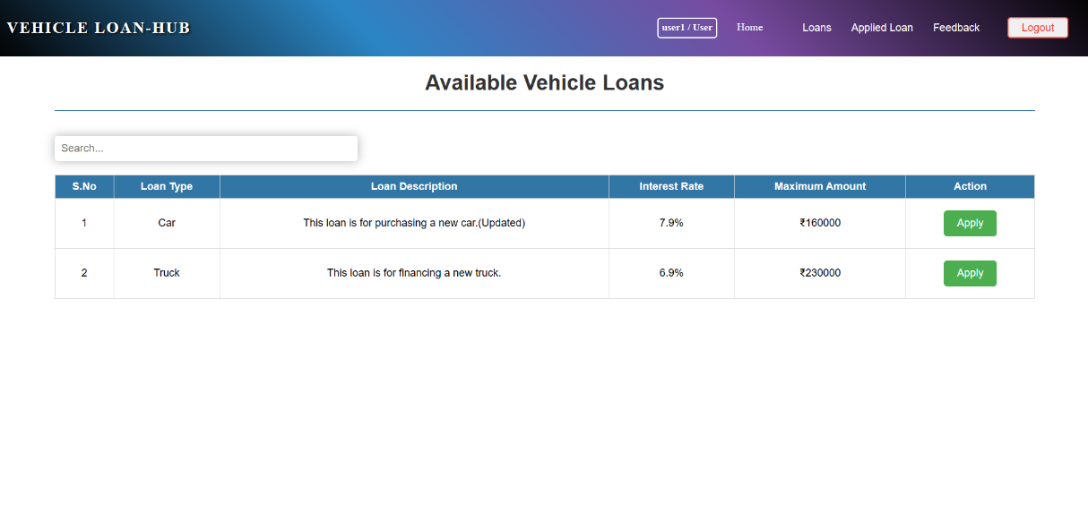

Clicking the "Apply" button will navigate to the **loanform component,** which displays a form with the heading "Loan Application Form". Additionally, it includes a "Back" button, which, when clicked, moves back to the **userviewloan component**

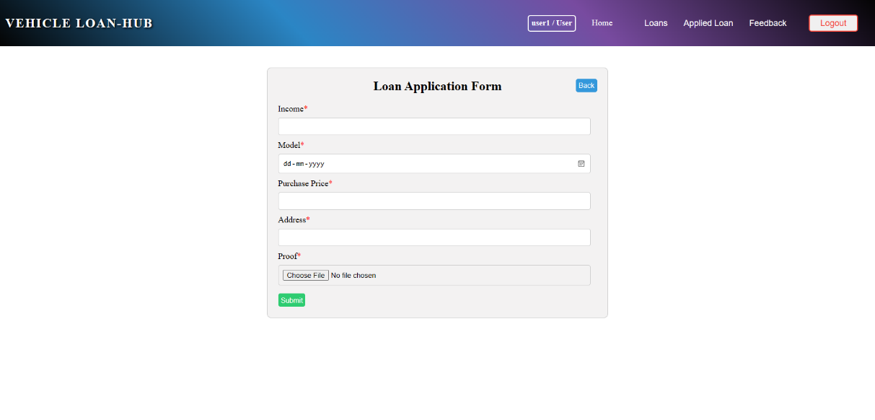

Perform validations for all the form fields.

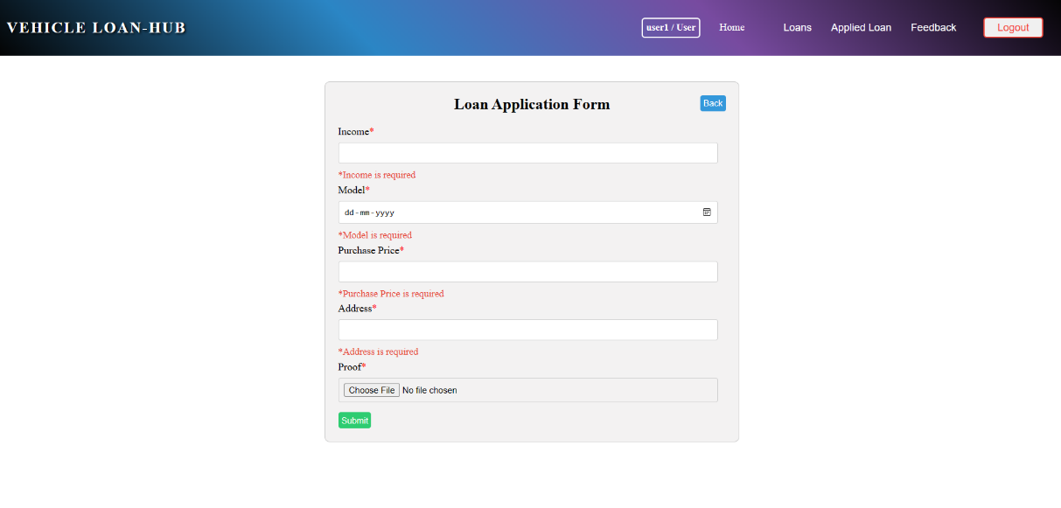

Clicking the "Submit" button with empty fields will display a validation message stating "All fields are required".

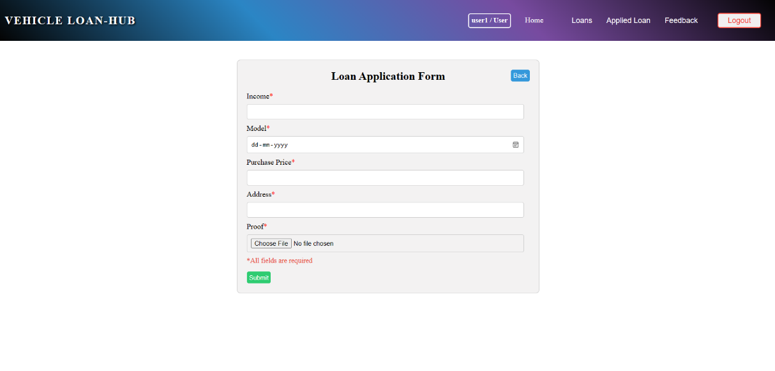

For the Model, future dates should be disabled, allowing only dates from the past to be selected.

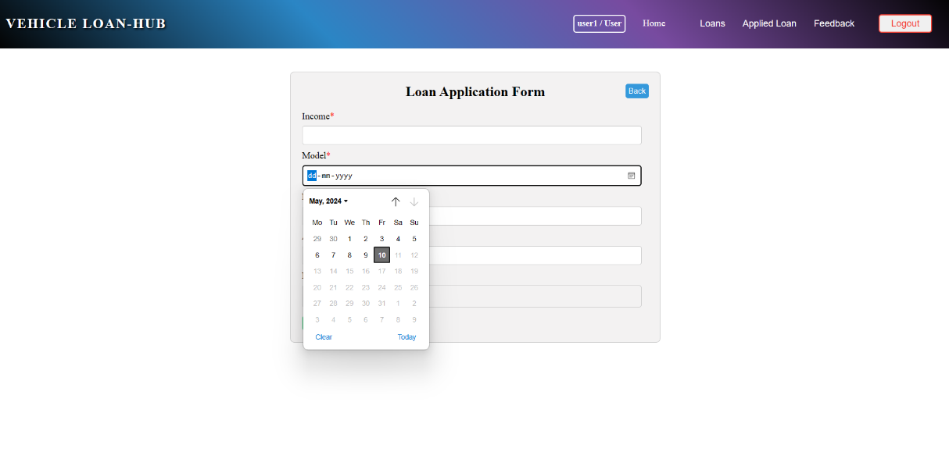

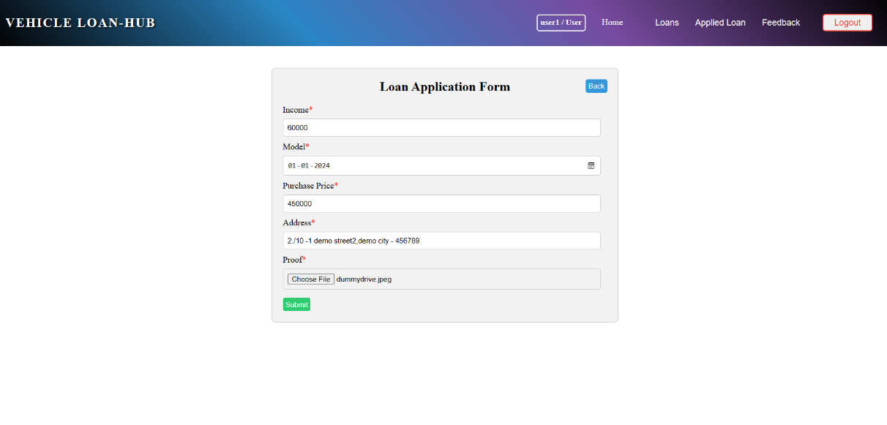

Upon clicking the "Submit" button, if the operation is successful, a popup message saying "Successfully Added!" should be displayed.

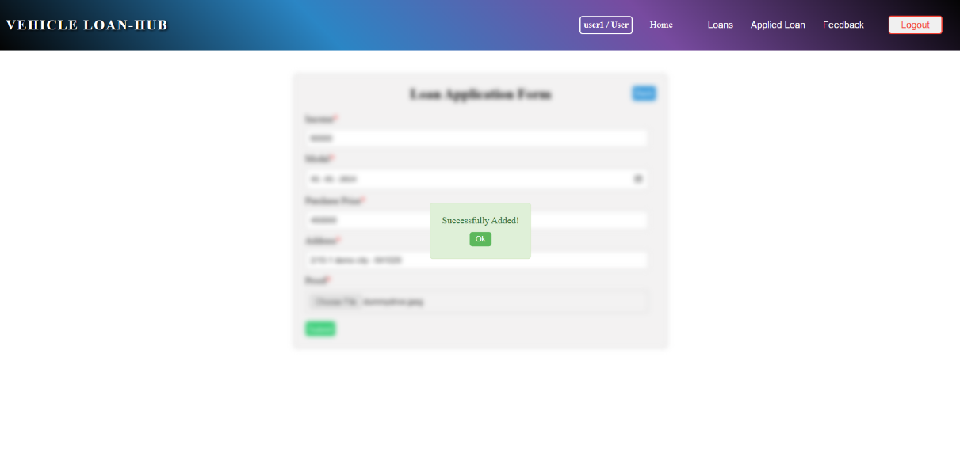

Clicking "Ok" will redirect to the **userviewloan component**. If the user has applied for the loan, it will display as "Applied"; otherwise, it will display "Apply".

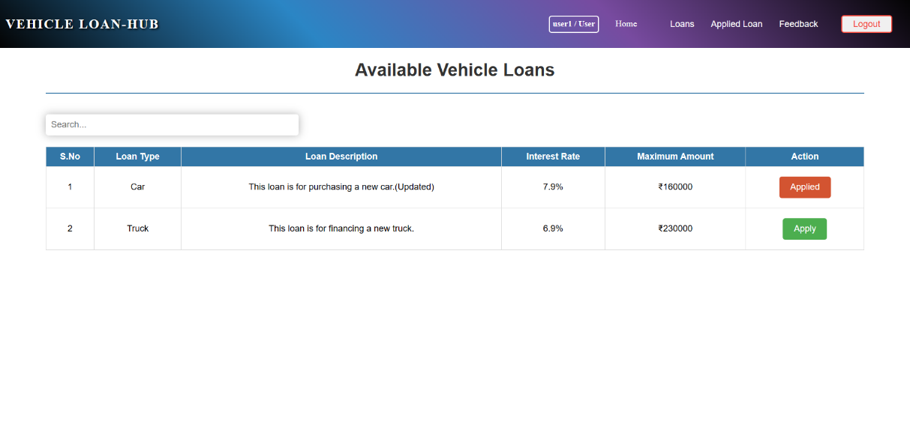

**User Applied Loan:**

Clicking on "Applied Loan" from the navbar will navigate to the **userappliedloan component**, which displays the user's applied loans.

If no data is available, then "Oops! No records Found" should be displayed.

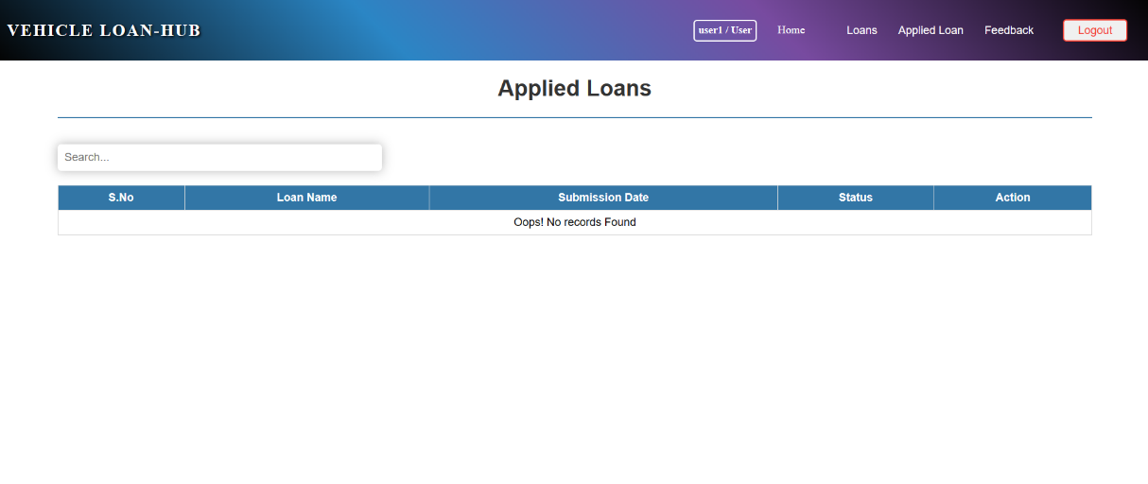

If data is available, the loans requested will be displayed in table format. Additionally, features such as the user being able to search based on Loan Name.

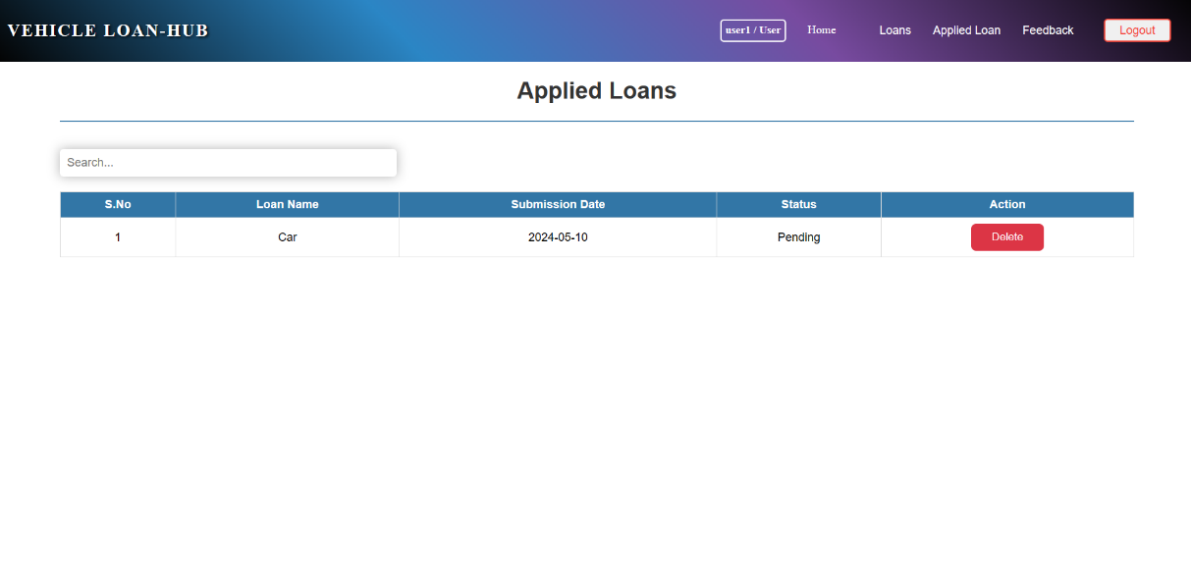

On clicking the "Delete" button, a pop-up should be displayed with confirmatory message to delete the data.

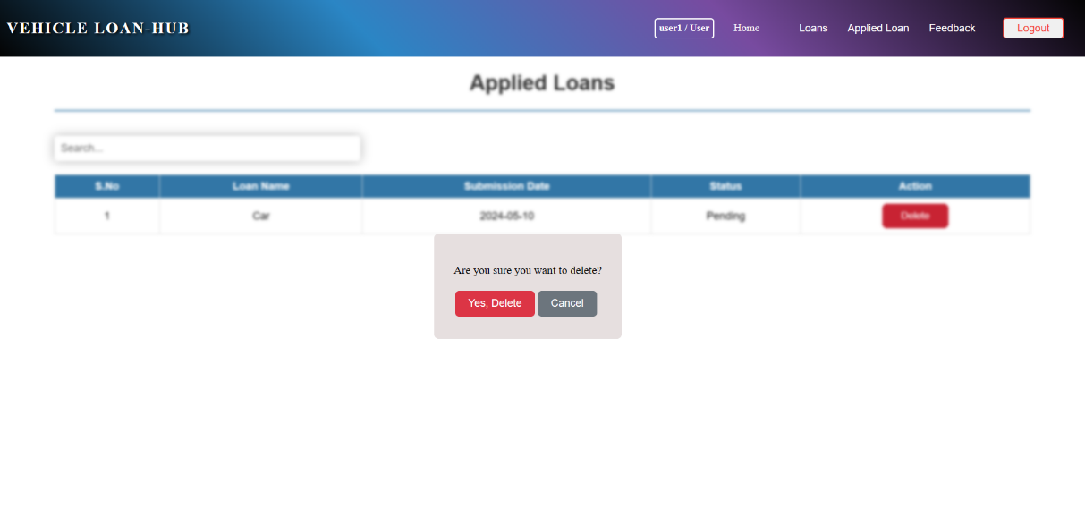

Clicking "Yes, Delete" will delete the applied loan, and the change will be automatically reflected.

**User Feedback:**

On hovering over the "Feedback" item in the navbar, a submenu should appear with options to "Post Feedback" and "My Feedbacks".

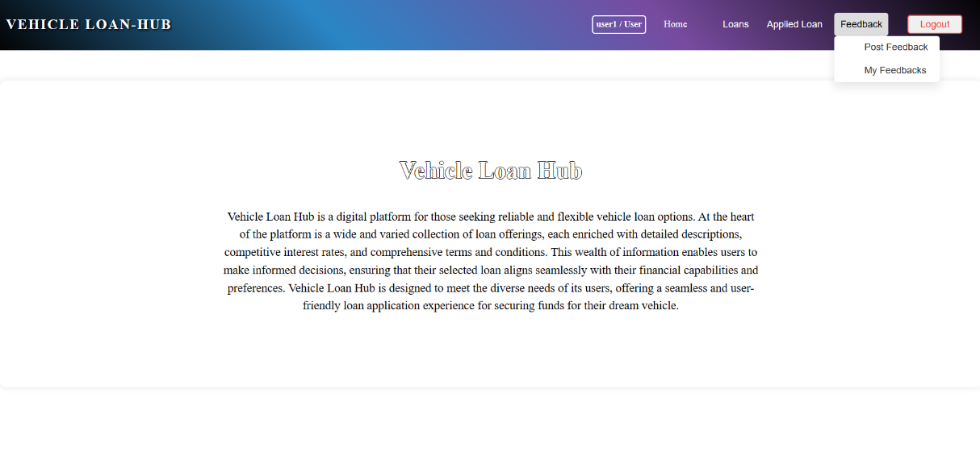

Clicking on "Post Feedback" will navigate to the **useraddfeedback** **component**, which displays the form to post feedback with heading as "Add Feedback"

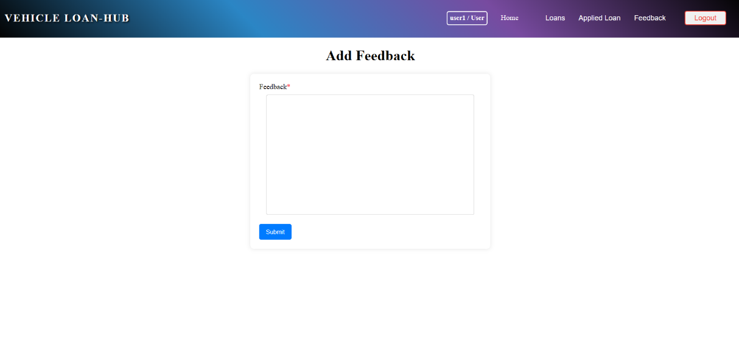

Clicking the "Submit" button with empty textarea will display a validation message stating "Feedback is required".

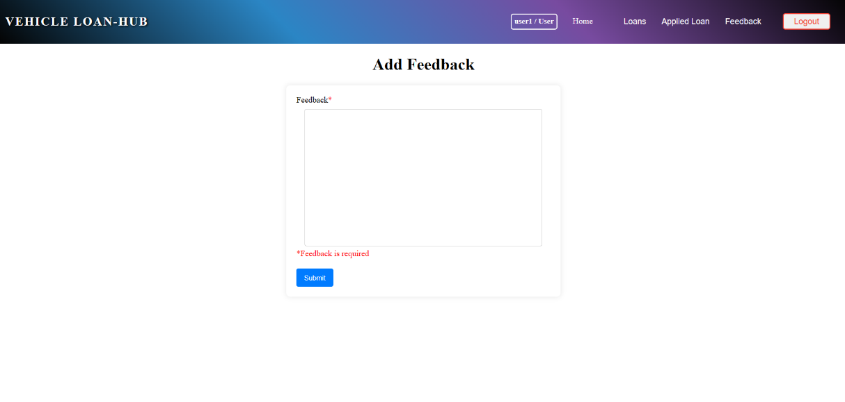

Upon clicking the "Submit" button, if the operation is successful, a popup message saying "Successfully Added!" should be displayed.

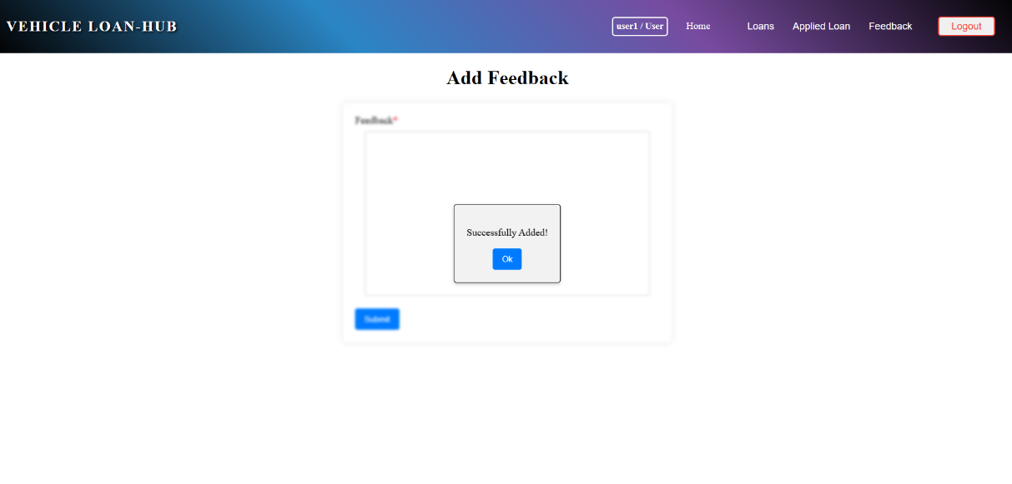

Clicking the "Ok" button will close the popup, and the same **useraddfeedback component** will be displayed.

**User view Feedback:**

On hovering over the "Feedback" item in the navbar, a submenu should appear with options to "Post Feedback" and "My Feedbacks".

Clicking on "My Feedbacks" will navigate to the **userviewfeedback** **component**, which displays posted feedback with heading as "My Feedback"

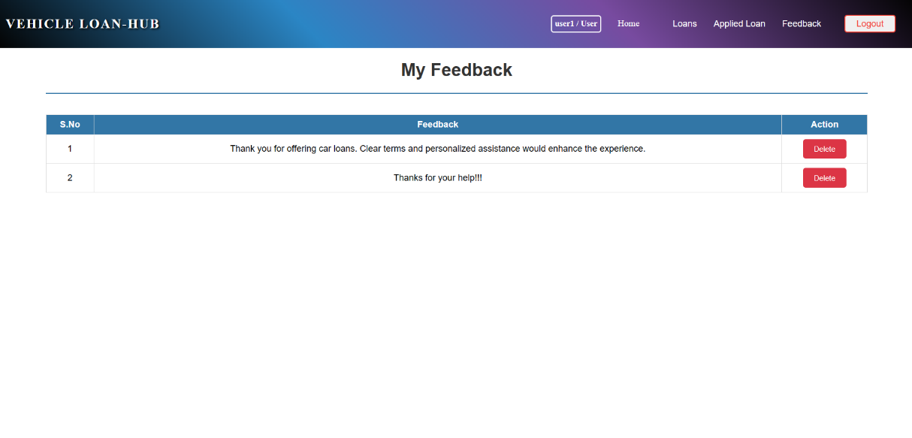

On clicking the "Delete" button, a pop-up should be displayed with confirmatory message to delete the data.

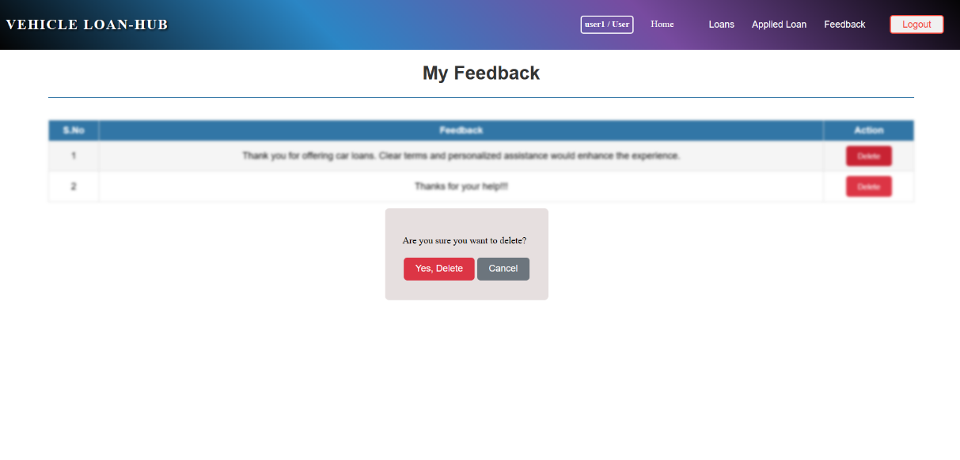

Clicking "Yes, Delete" will delete the feedback posted, and the change will be automatically reflected.

On clicking the "Logout" button, a pop-up should be displayed with confirmatory message to logout the user.

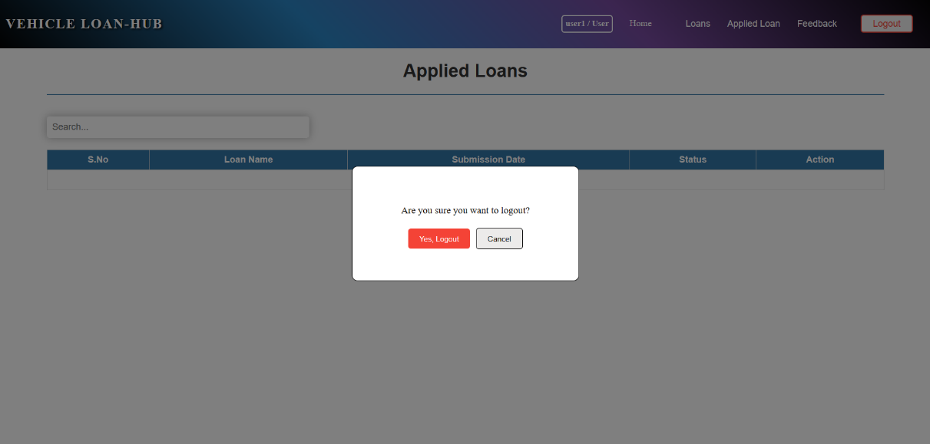

Clicking "Yes, Logout" will navigate to the login component.

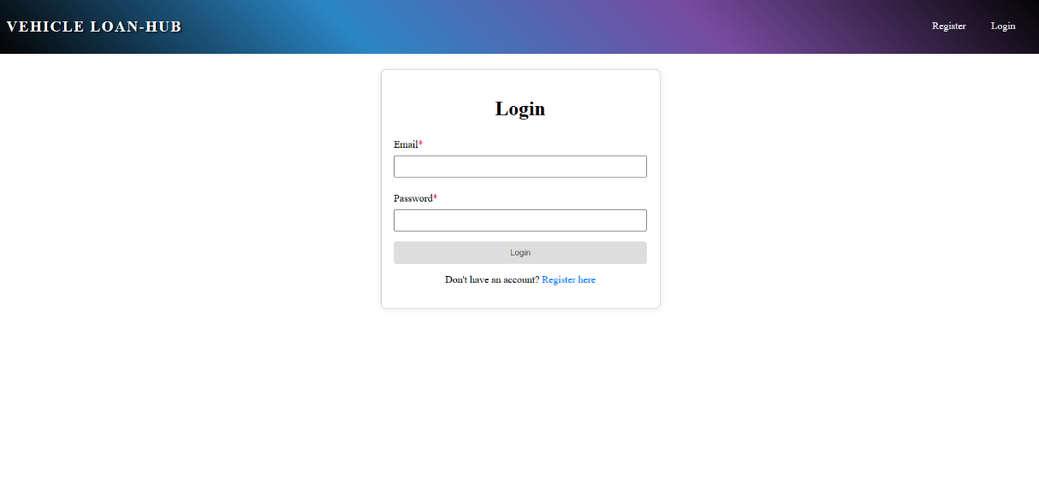

error component

This page displays an error message stating "Something Went Wrong".

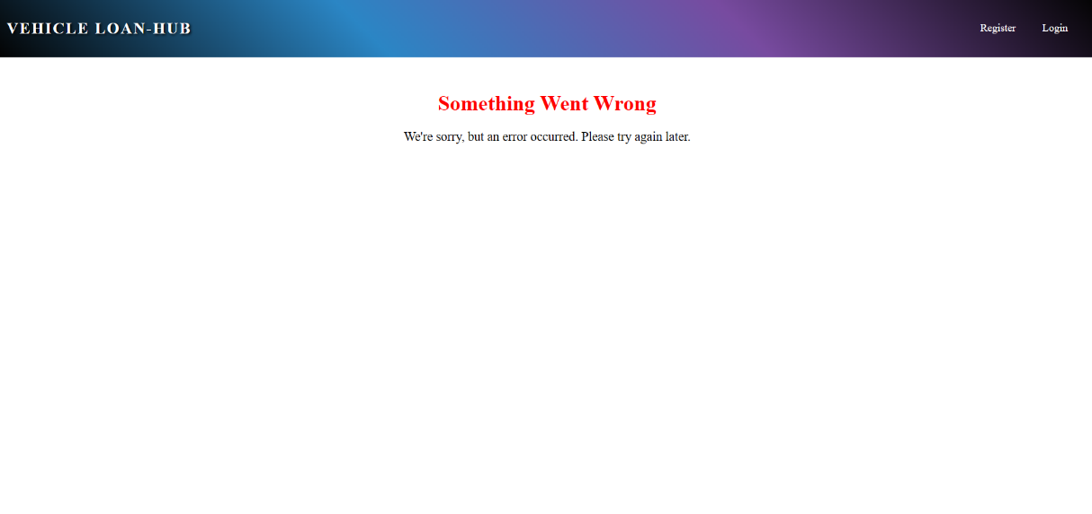

**Platform Prerequisites (Do’s and Don’ts):**

1. The angular app should run in port 8081.
2. The dotnet app should run in port 8080.
3. To incorporate .Net Security into the application, use JWT authentication within the project workspace.

**Key points to remember:**

1. The id (for frontend) and attributes(backend) mentioned in the SRS should not be modified at any cost. Failing to do may fail test cases.
2. Remember to check the screenshots provided with the SRS.
3. Strictly adhere to the proper project scaffolding (Folder structure), coding conventions, method definitions and return types.
4. Adhere strictly to the endpoints mentioned in API endpoints section.
5. Don't delete any files in a project environment.

**HOW TO RUN THE PROJECT:**

**BACKEND:**

Open the terminal and follow the commands below.

* **cd dotnetapp**

Select the dotnet project folder

* **dotnet restore**

This command will restore all the required packages to run the application.

* **dotnet run**

To run the application in port 8080

* **dotnet build**

To build and check for errors

* **dotnet clean**

If the same error persists clean the project and build again

To work with Entity Framework Core:

Install EF using the following commands:

**dotnet new tool-manifest**

**dotnet tool install --local dotnet-ef --version 6.0.6**

**dotnet dotnet-ef** --To check the EF installed or not

**dotnet dotnet-ef migrations add "InitialSetup"** --command to setup the initial creation of tables mentioned in DBContext

**dotnet dotnet-ef database update** --command to update the database

**To Work with SQLServer:**

(Open a New Terminal) type the below commands

**sqlcmd -U sa**

password: **examlyMssql@123**

>use DBName

>go

1> insert into TableName values(" "," ",...)

2> go

**Note:**

1. Please ensure that the application is running on port 8080 before clicking the "Run Test Case" button.
2. Database Name should be **appdb**
3. **Use the below sample connection string to connect the Ms SQL Server**

**﻿connectionString = "User ID=sa;password=examlyMssql@123; server=localhost;Database=appdb;trusted_connection=false;Persist Security Info=False;Encrypt=False";**

**FRONTEND:**

Open the terminal and follow the commands below.

**Step 1:**

**• Use "cd angularapp**" command to go inside the angularapp folder

• Install Node Modules - "**npm install**"

**Step 2:**

• Write the code inside src/app folder

• Create the necessary components

• To create Service: "**npx ng g s <service name>**"

• To create Component: "**npx ng g c <component name>**"

**Step 3:**

• Click the **Run Test Case** button to run the test cases

**Note:**

• Click PORT **8081** to view the result / output.

• If any error persists while running the app, delete the node modules and reinstall them.